THE OFFICIAL PUBLICATION OF ALOA - AN INTERNATIONAL ASSOCIATION OF SECURITY PROFESSIONALS

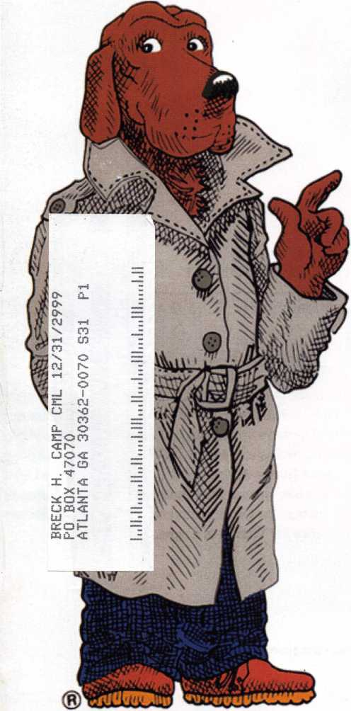

Key into  
Crime  
Prevention

***Now More Than Everya Time to Stress Security***



TAKE A BITE OUT OF



**3M's New Heavy Duty Window Film Kantech Access Control FireKing University An Okie Institutional Grand Prix Opening ALOA Store Info. And Terrorist Tragedy Letters**

**Renew or Apply for Membership ONLINE at [www.aloa.org](http://www.aloa.org)**

**During times of crisis, unity is key. Right now, when you join ALOA  
Cor renew your membership), you will receive, free of charge,  
this patriotic decal for your shop or van, which serves as a  
special reminder to you and your customers that it takes  
a spirited effort to strengthen the ties that bind us.**

**AIOA locksmiths Secur&America**

**Decal dimensions 8y2" x 5'/«"**

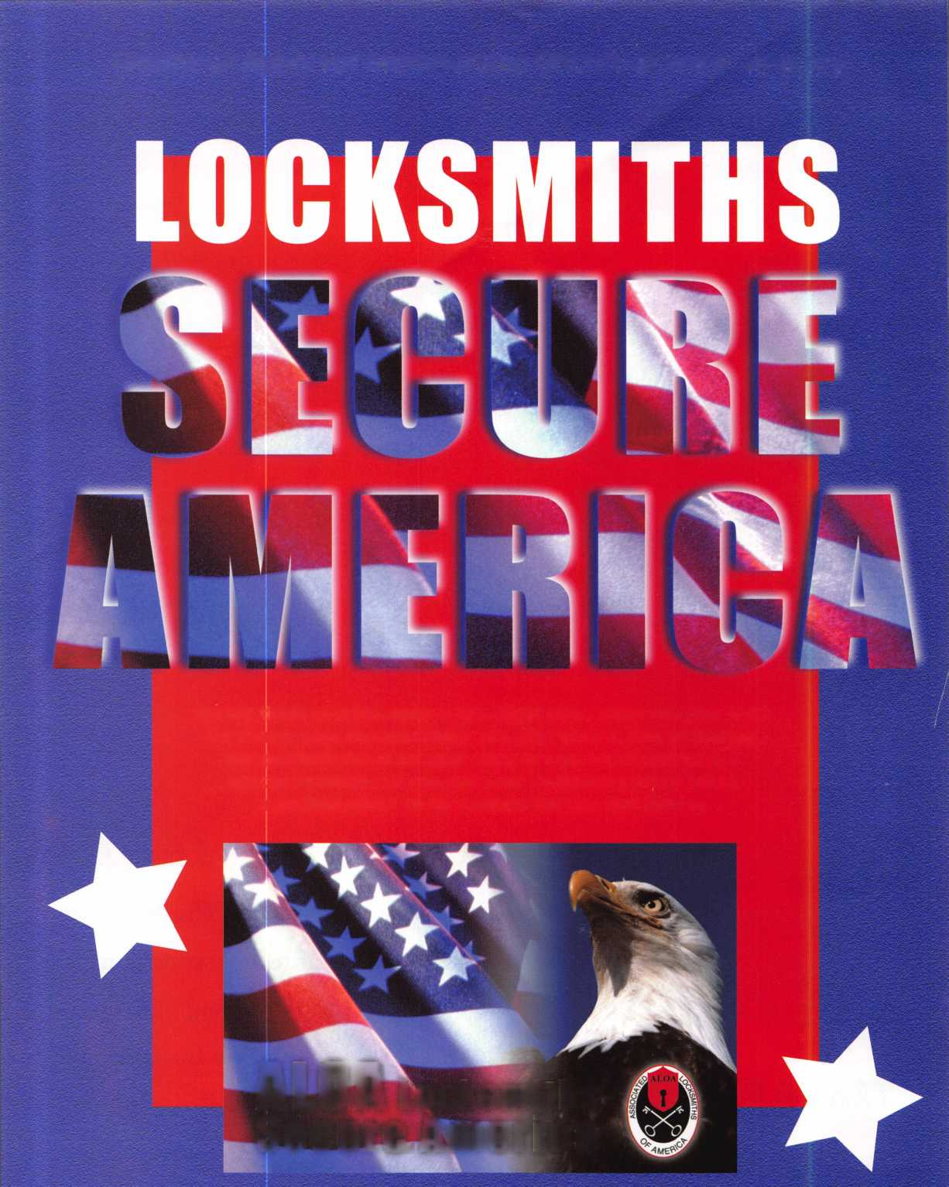

• • tf

r * ||

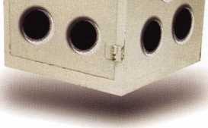

**April 8-13**

**John Ascuaga's Nugget Resort • Reno, Nevada**

reno, nevada



2

Contents

October 2001

Volume 47, Issue 9

(0

Ul

D

H

<

Li.

14 Special Triple Feature Crime Prevention Month Part 1: Key into Crime Prevention Month.

Opportunities to raise the public awareness about crime prevention are all around you each October. Partnering with national organizations like the NCPC help your exposure and helps your customers stay abreast of the latest security products.

By Claire Cohen, CML

Part 2: Crime Prevention and the Security Professional.

Defining yourself as a crime prevention professional in today's secu­rity-starved market.

By Jim Hancock, CRL

Part 3: Foiling the Smash-and-Grabbers.

A new heavy-duty window film from 3M withstands 400 pounds of pressure - a nice option for home and business owners who want their windows secured and energy efficient.

By Jim DeSimone, editor

20

Access Control: Kantech Access Control

Keep yourself in the customer's mind by tailoring your bids to meet different needs. In this case, it was an office that needed some modification to its access con­trol system, but not necessarily a complete overhaul.

By Greg Perry, CML, CPS

24

Safes: FireKing University

Step inside the impressive safe manufacturing fortress at Fire King, and you'll find a lot more than you bargaino I for.

By Don Dennis, CPL

28

Automotive: A Grand Prix Opening

Step by step, with specific tip: Ion how to speed up this potentially tricky process. By Ken Holmlund, CRL

32

Success Breeds Confidence

Selling yourself in today's competitive marketplace.

By John Elliott Jr., CML, CPS

34

Institutional: An Okie Institutional

Charles Hudecek is "THE" locksmith at Cameron University in Norman, Okla­homa. Step inside his world for tips on today's institutional challenges.

By C.D. Lipscomb, CML, CPS

DEPARTMENTS

2

Contents

President's Journey

6

Upcoming Events 8

Core

10

Applicants

12

Letters to the Editor

36

Legislative Update 40

Classifieds

42

Associate Member Listing 44

Back Page

VISIT OUR WEB SITE AT:  
[www.aloa.org](http://www.aloa.org)

2

Keynotes

October 2001

Executive

Editor Jim DeSimone

[editor@aloa.org](mailto:editor@aloa.org)

Technical Editor David Lowell, CML, CMST

[david@aloa.org](mailto:david@aloa.org)

Editorial Advisor John D. Cannon, CML

[jdcannon@worldnet.att.net](mailto:jdcannon@worldnet.att.net)

Advertising Sales Susan Haverkamp

121 Davis Street Nacogdoches, Texas 75961 Phone: (936) 569-7172 VoiceMail: (208) 248-8893 e-mail: [adsales@aloa.org](mailto:adsales@aloa.org)

Contributors Jerome Andrews, CML

Paul Chandler, CRL Claire Cohen, CML Brian Costley, CML, CMST Ray D'Adamo, CML Sal Dulcamaro, CML Billy Edwards, CML Dan Graffeo, CRL,CMST A.J. Hoffman, CML Jeff Nunberg, CML, CMST Mike Oehlert, CPL, CPS Randy Simpson, CML Robert Stafford, CML Dave Thielen, CML Greg Perry, CML,CPS Tom Seroogy Charles Stephenson, CPS Dennis Watanabe, CML, CMST

|  |  |
| --- | --- |
| Executive Director | Charles W. Gibson, Jr., CAE [charlie@aloa.org](mailto:charlie@aloa.org) |
| Director of Information Technology | Randy McChristian [randy@aloa.org](mailto:randy@aloa.org) |
| Convention & Meetings Manager | Kelly Carr, CMP [kelly@aloa.org](mailto:kelly@aloa.org) |
| PRP/Education Manager | David Lowell, CML, CMST [david@aloa.org](mailto:david@aloa.org) |
| Operations/Membership Manager | Mary May [mary@aloa.org](mailto:mary@aloa.org) |
| Government Affairs Manager/ | Tim McMullen |
| Chapters & Regional Associations Liaison | [tim@aloa.org](mailto:tim@aloa.org) |
| Comptroller | Kathy J. Romo |
| Network Specialist | GregJackson |
| Membership Coordinator | Shelly Jett |
| Convention & Meetings Assistant | Karen Lyons, [Karen@aloa.org](mailto:Karen@aloa.org) |
| PRP/Education Coordinator | Ashley Manson |
| Accounting Coordinator | Kathy Stokes |
| Mail Room Coordinator | Humberto Cerda |
| Receptionist | Alin Valdez |

Additional contact information for the

ALOA Board and most Keynotes authors is available through “Locksmith Search’”

on the ALOA Web site- [www.aloa.org](http://www.aloa.org) or by contacting the ALOA office at 3003 Live Oak Street;

Dallas, TX 75204;

**(**800**)**532**-**2562**;**

FAX (214)827-1810; e-mail [aloa@aloa.org](mailto:aloa@aloa.org).



Mission Statement: The Associated Locksmiths of America, Inc. is dedicated to enhancing the professionalism, education and ethics among locksmiths and those in related sectors of the physical security industry. With approximately 10,000 members in the United States, Canada and the freeworld, ALOA is poised to help members obtain the knowledge, the strength, and the confidence to perform their role in the physical security field with pride and dignity. But it is only through active involvement and participation that ALOA can fully achieve its potential—and can help members to achieve theirs.

Policies: Keynotes® is the official publication of the Associated Locksmiths of America, Inc. (ALOA). Keynotes® acts as a moderator without approving, disapproving, or guaranteeing the validity or accuracy of any data, claim, or opinion appearing under a byline or obtained or quoted from an acknowledged source. The opinions expressed by the authors do not necessarily reflect the official views of ALOA. Also, appearance of advertisements and new products or service information does not constitute an endorsement of products or services featured by the Association. The Association does not accept responsibility for the inaccuracy of any data, claim, or opinion appearing in this publication, due to typographical errors on the part of the authors, Association staff or its agents.

Editor’s Note: This publication is designed to provide accurate and authoritative information in regard to the subject matter covered. It is provided and disseminated with the understanding that the publisher is not engaged in rendering legal or other professional services. If legal advice and other expert assistance is required, the services of a competent professional should be sought.

Authors’ Payment: Payment for eligible submissions to Keynotes will be based on the following criteria: topic, time spent and past contributions. Authors who regularly submit to Keynotes are generally paid a higher rate. The latter is especially true of authors who write to fit specific editorial needs and submit said copy by Keynotes deadlines. As a general guideline: Average payment for a 750 word, business or ‘light’ technical article would be $200. Payment for a 1500 word article involving significantly higher time and research efforts would be $400.

Payment will not be offered for articles submitted by ALOA employees or members of the ALOA Board of Directors (unless material is of a technical nature), nor for articles submitted by a company that promote that company’s products or services. ALOA reserves the right not to pay for articles submitted by an individuals) that promote a particular company’s products or services.

Disclaimer: The Associated Locksmiths of America, Inc., (ALOA), reserves the right to refuse any article for any reason. Additionally, ALOA reserves the right to edit, amend or modify any article submitted for publication in order to preserve technical accuracy, clarity, fairness or grammatical correctness. ALOA will make the best efforts to notify the author of any changes. The extent of ALOA’s liability for any article or information contained therein will be a notice of cor­rection or retraction in the next possible issue.

Keynotes® (ISSN 0277 0792) is published monthly except for the combined June/July issue by The Associated Locksmiths of America, Inc., 3003 Live Oak St., Dallas, TX 75204-6186. Telephone: (214) 827-1701; FAX (214) 827-1810; e-mail [aloa@aloa.org](mailto:aloa@aloa.org). Subscription rates for members—$15.00 per year. Second class postage paid at Dallas, Texas. POSTMASTER: Send address changes to: Keynotes, 3003 Live Oak St., Dallas, TX 75204-6186. © Copyright 1999, All rights reserved. No part of the contents may be reproduced or reprinted in any form without prior written permission of the publisher.

President

Randy Simpson, CML (713) 780-7026 [president@aloa.org](mailto:president@aloa.org)

Secretary

John D. Cannon, CML (703) 960-6413 [jdcannon@worldnet.att.net](mailto:jdcannon@worldnet.att.net) Directors, Northeast John C. Magee, III (856) 845-3434 Peter Sarailian, CRL (201) 947-6291 [psarailian@yahoo.com](mailto:psarailian@yahoo.com) William L. Young, CML (610) 647-5042 Directors, Southeast Vincent Formon, CML, CPS (901) 324-2910 Donald E. Rule, CML (601) 324-2658 [rulecml@ebicom.net](mailto:rulecml@ebicom.net) Directors, North Central Mark E. Blum, CML, CPS (517) 482-5809 [mblum@arq.net](mailto:mblum@arq.net) John Soderland, CML, CMST (414) 327-5625 [ncdirector@aloa.org](mailto:ncdirector@aloa.org) Director, South Central Randy L. Simpson, CML

1. 780-7026 Directors, Southwest Gordon R. Racine, CML (719) 384-4707 [swdirector@aloa.org](mailto:swdirector@aloa.org) Julie McCluney, CRL
2. 636-5652 [swdirector@aloa.org](mailto:swdirector@aloa.org) Director, Northwest Scott L. Henke, CRL, CPS (907) 248-3785 [action@alaska.net](mailto:action@alaska.net) Director, Associate Members David F. Matthies

(727) 541-5536

[dmatthies@southernlock.com](mailto:dmatthies@southernlock.com)

Trustees

John J. Greenan, CML, CPS (773) 486.2030 Dallas Brooks (334) 826-8990 David M. Lowell, CML, CMST (800) 532-2562 Edwin Toepfer, RL (416) 225-5589

Past Presidents

1999-2001

1997-1999

1995-1997

1993-1995

1991-1993

1989-1991

1987-1989

1985-1987

1983-1985

1981-1983

1979-1981

1977-1979

1974-1977

1972-1974

1970-1972

1968-1970

1966-1968

1964-1966

1962-1964

1960-1962

1956-1960

John Greenan, CML, CPS Dallas C. Brooks David Lowell, CML, CMST Breck Camp, CML Henry Printz, CML Evelyn Wersonick, CML, CPS Leonard Passarello, CPL Joe Jackman, CML Stanley Haney, CPL Louis LaGreco, CPL John Kerr, RL Clifford Cox, CML Charles Hetherington Gene Laughridge William Dutcher, RL Constant Maffey, RL Harold Edelstein, RL William Meacham Robert Rackliffe, CPL Edwin Toepfer, RL Ernest Johannesen

October 2001

***Keynotes \*** 3

President's , „

Hello Members,

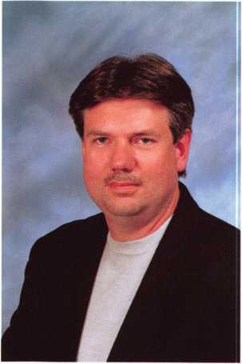

October is Crime Prevention month. Although it's a little late to start a special promotion, you can feel good about what you do. As one of the world's oldest profes­sions, we make sure bad things don't happen to good people. How many possessions or valuables have you been associated with protecting? Even more importantly, how many lives have you protected? Wow, I feel good! As an association, our group has done these two things for millions of people and businesses. Do something special for yourself and remember how important you are.

Legislation in North Carolina has been passed and signed into law, a huge win for our industry (see page 36 to read about this). But our profession faces big challenges from the NBFAA and other state burglar associations. Let me rename them. The NBFAA board was considering a name change to become the "Electronic Security Systems Association." Tim McMullen, our staff manager for Government Affairs, is monitoring their intent to "define their destiny rather than allowing others to do it for them." As an association, ALOA must acquire this same attitude. Protecting our members rights to sell service and install "Electronic Security Systems," is paramount.

You will find the ALOA Board in Portland Oregon October 18-21,2001. We will be holding our Fall Board Meeting and supporting the Pacific Locksmith Association by attending their Tri-Regional Locksmith Conference. We are currently working on our agenda. The legislative items previously mentioned are included as well as concerns and goals we must address. We will work on several issues at this meeting, which will produce positive results for our members. I am confident that this current board will make decisions that will add value from our association for each of our members. I look forward to seeing many of you in Portland.

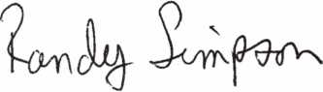

A

Keynotes

October 200 **7**



***Visit our Website on  
www: stamcctv. com***

**THE COMPLETE**

**CCTV PROGRAM ON CDgROM  
FOR STAFF TRAINING AND  
PRODUCTIVITY ENHANCEMEN**

STAIN/! Insight has been  
developed to enhance CCTV  
skills and productivity with  
many different uses.

10 Productivity

W System Drawing  
10 Estimation  
10 CCTV Training  
10 CCTV Reference  
10 Sales/Demo  
t0 System Design  
10 Staff Evaluation

|  |  |  |
| --- | --- | --- |
|  | | INFOMATE WORKMATE ULTIMATE^^ |
| ©  u  1  cc | CCTV Content | 10 hours 10 hours ! 14 hours |
| CCTV Calculators | s X / f |
| Demonstration Tool | ^ f 'f |
| Productivity j Tod | Estimation | No f f |
| Drawing | No ' ^ ' |
| Internet Enabled | No / / |
| | Training | ' Pre-Test | Ho Ho |
| Quizzes | no ^ IT'" * ~ f |
| A Knowledge Assessment | No No f |

**Sold in Over 50 Countries**

.. -

Distributed by:

3003 Live Oak Street  
Dallas,Texas 75204



Name:

Job Title:

Organization:. Address:

Zip/Postcode

e-mail

Fax: ( )

COPYRIGHT © 1996 Security Training and Marketing Pty Ltd. All rights reserved ACN 057 006 541

Country

Tel: ( )

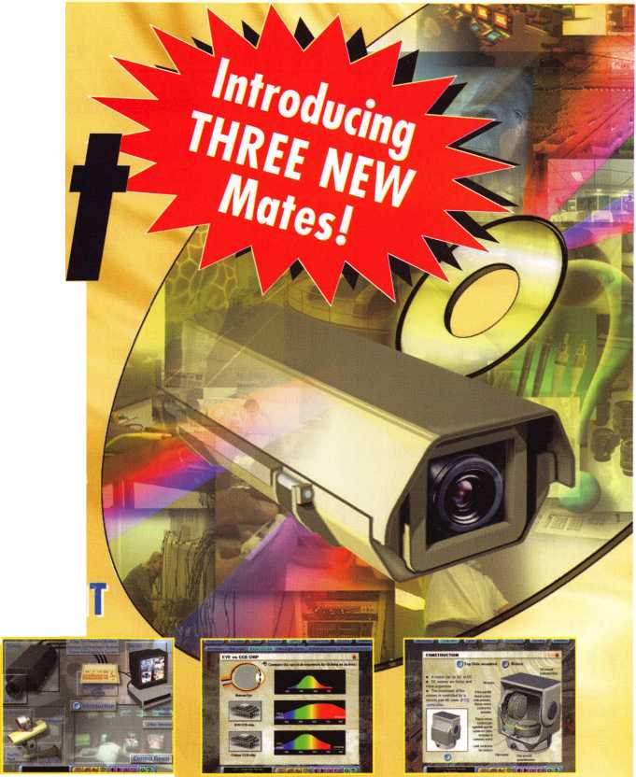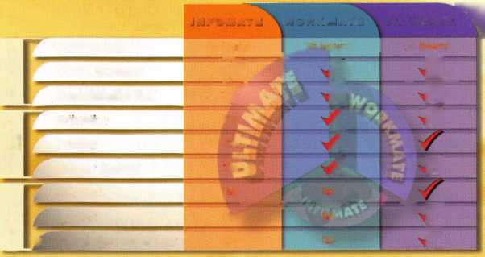

e

v

e

n t s

OCTOBER

3-7

/ SERLAC

Education, Trade Show and Banquet

Jacksonville, FL

800/845-5294

7-11

Yankee Security Convention 12 ACE Classes Sturbridge, MA Contact: Stephen McKinney (617) 789-3274

OCTOBER

5

Casper, Wy

fundamental Impressioning Contact: GeneFicek

17

+ ALOAPRP Sitting Grand Canyon Chapter of ALOA Contact: John Ilk, CML (602) 574-5277

12-14

Jo-Van Distributors, Inc.

Annual Trade and Educational Show (416) 752-2238

12

ffr ALOA PRP Sitting Dallas, TX

Contact: Ashley Manson

(214) 827-1701 FAX (214) 827-1810

15-21

^ Tri Regional Locksmith Conference 13 ACE Classes and PRP Sitting Portland, OR

Pacific Locksmith Association Contact: Stan Hauer (503) 325-7334 Email [hauer@pacifier.com](mailto:hauer@pacifier.com) Contact: Ken Mead (503) 873-6932

20

Northern Prairie Chapter of ALOA ACE Class-Combination Lock Servicing and Troubleshooting Fargo, ND

Contact: Todd Ludwig, CML (701) 232-9440

27

Grand Canyon Chapter of ALOA Security Resources Seminar w/Steve Young Bostrom High School Phoenix, AZ

Contact: John ILK, CRL, CPS (602)5745277

NOVEMBER

9

p ALOA PRP Sitting Dallas, TX

Contact: Ashley Manson 800/532-ALOA (2562)

17-18

Tulsa, OK

Oklahoma Locksmith Association Cylinder Servicing,

Lockset Functions & finishes, And Lockset Servicing Contact: Charles Hudecek 580/352-3232

DECEMBER

14

& ALOA PRP Sitting Dallas, TX

Contact: Ashley Manson 800/532-ALOA (2562)

January

19-20

Poison, MT

Montana Chapter of ALOA 2-Day Foreign Auto Contact: Todd Rasmussen, CRL 406/883-2950

SAFETECH 2002

April 8-13 Reno, NV Contact: ALOA

(800)532-2562 or (214)827-7233 (SAFE)

[www.savta.org](http://www.savta.org)

[dialcenter@aloa.org](mailto:dialcenter@aloa.org)

ALOA 2002

July 22-28,2002 Rosemont, IL Contact ALOA 800/532-2562 [www.aloa.org](http://www.aloa.org) [aloa@aloa.org](mailto:aloa@aloa.org)



\_ Indicates ALOA ACE Class #*■ Indicates PRP Sitting

***Keynotes***

October 2001



new

affordable

price!

Super strong rare earth magnets

ial gripper with reversible shaped

jaws to grip most dials

Easy to assemble mounting jig  
Self contained - no computer required

(

Phone: (888) 264-6627 |P|M% A | 2639-B Progressive Way

(604) 852-8904 II I I TALv/ **ViV** Abbotsford, B.C.

USA: (562) 699-0060 **TOOLS LIMITED U**2**T**6**H**8

Seruing industry with superior products since 1985.

October 2001

Keynotes

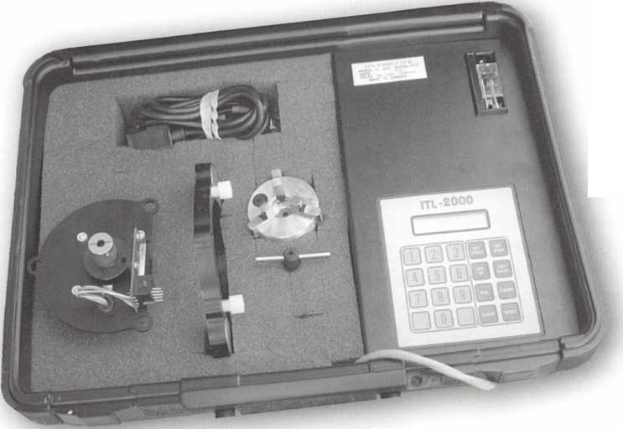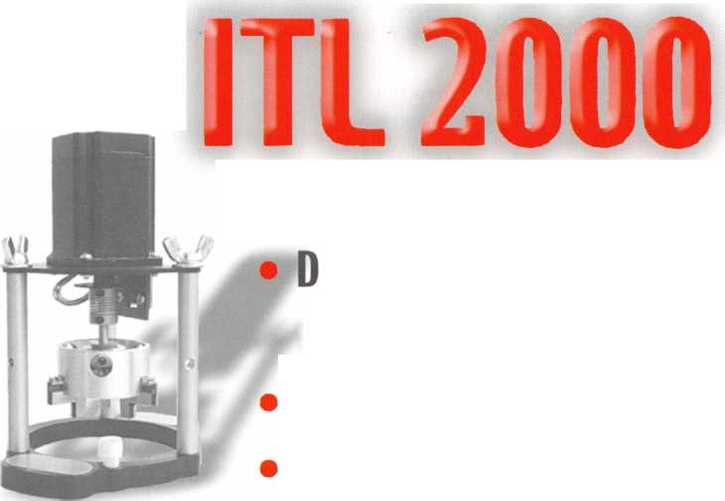

CORE

In the Wake of Mosler...

Mosler recently announced it had ceased all operations in order to engage in an orderly liquidation of its assets. At the time, all 1,800 Mosler employees were terminated. The company retained only a small core group of employees to assist in the liquidation process.

Mosler said that it explored a number of actions, including a sale of the company and various restructuring alternatives, and was subsequently bought by ADT Security Services, Inc.

In the meantime, Diebold Incorporated has delivered customer service to Mosler's customers. In a statement made by Walden W. O'Dell, chair­man, president and CEO of Diebold, the support of both Mosler cus­tomers and former employees was given. "We intend to respond quick­ly to immediate customer needs arising from this unfortunate situa­tion," he said. "We are also greatly concerned about the 1,800 former employees of Mosler and we hope to accommodate as many of them as possible in our organization as we expand our service operations to meet our increasing customer service requirements."

The latest development in the Mosler liquidation saga was a recent announcement that ADT had created a new Financial Services and Banking Division created specifically to meet the increased demands of the electronic and physical security marketplace. The new division will be lead by former Mosler Chief Operating Officer, David Artone. In addition, nearly a thousand former Mosler employees will be filling var­ious positions within the division.

According to ADT's President, Michael Snyder, "The new Financial Services and Banking group will combine both the strengths of ADT and those formerly held by Mosler - ultimately creating a group that can provide superior electronic and physical security to financial insti­tutions. ADT has experienced significant growth in the financial servic­es arena in recent years and this new division should provide addition­al market expansion. We also expect this division to have an immediate and positive impact on the marketplace."

PRP Scorecard

Periodically, we like to publish the current total number of our mem­bers who have been certified in our unequalled proficiency registration program. We urge more of our members to seek a PRP designation. The current breakdown by designation is as follows:

CRL 2,634 CPL 614 CML 687

The average age of our certified locksmiths is tightly ranged between

the ages of 37 and 39. Our oldest certified members are 89 years old.  
Our youngest certified members are only 15!

New CRLs

David Armour  
Timothy Bouis  
Jason Belanger  
Paul Carchia  
Elliott Connor  
James Damien  
Robert Deck  
Jeff Emily  
Michael Festa  
Jim Holmes  
Richard Malanowski  
Matt Marhan  
Bradley Polega  
Thomas Reeves-Messner  
Edward Saladin  
Kevin Savoy  
Glen Schoenberg  
Daryl Seiple  
Michael Stilwell  
David Welter

|  |  |
| --- | --- |
| New CPLs | |
| Raiford Ball | Jefferson City, TN |
| Austin Curry | Tampa, FL |
| Andrew Edmonds | New London, NH |
| Curtis Jones | Lexington, KY |
| CMLs | |
| Thomas Gillingham, Jr. | Antioch, TN |
| James D. Turner | Dothan, AL |
| CPSs | |
| Jason Belanger | Little Britain, CN |
| Andrew Edmunds | New London, NH |
| John Elliott | Conyers, GA |
| Thomas Gillingham, Jr. | Antioch, TN |
| John Ilk | Tempe, AZ |
| Jim Jeffries | Lewiston, ID |
| Walter Peterson | Priovolake, MN |
| Dale Shaw | Salisbury, MD |
| Thomas Uhlig | Meadville, PA |

Joppa, MD Taneytown, MD Little Britain, CN Arlington, VA Springfield, VA Gainesville, FL Burlington, KY Fairfax, VA Bohemia, NY Peoria Heights, IL Phoenix, AZ Long Beach, NY Grand Rapids, MI Sunnyvale, CA Schererville, IN Levithown, PA Alexandria, VA York, PA Madison, WI Davie, FL

Keynotes

October2001

>

*'&&$A*

^W ^ "ace ASSA

• cy"ndere.tere

With ASSA, all the pieces are now in place.

With ASSA cylinders you never have to worry about missing pieces in your

twin V-10

school’s lock system. ASSA has cylinders to fit into any standard, grade 1

, lock used in schools and institutions today.

And the good news is that you don’t have

to change all of your hardware to take

advantage of ASSA’s patent-protected key  
control. Tighten security with ASSA locks.

ASSA, Inc., 110 Sargent Drive, New Haven, CT 06511, (800) 235-7482, Fax (800) 892-3256 [www.assalock.com](http://www.assalock.com)  
ASSA Canada, 3475 14th Avenue, Markham, Ontario L3R OH4 Canada

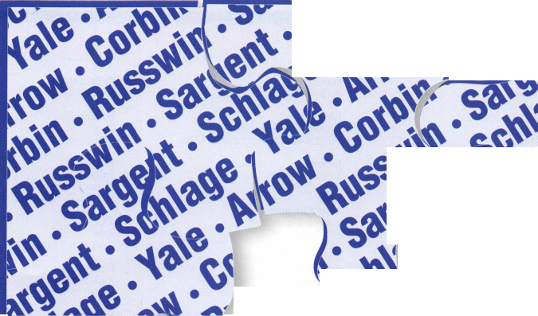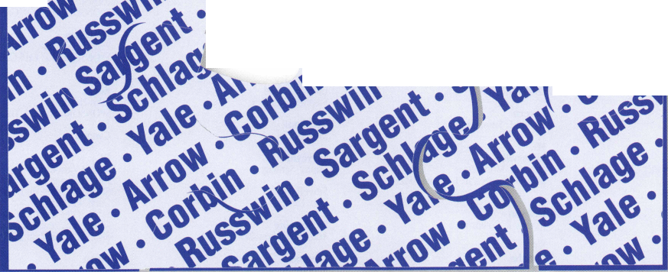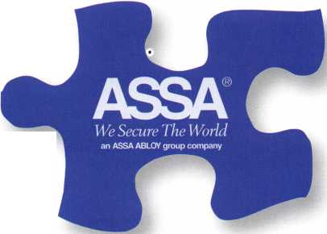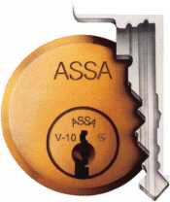

membership

CA

El Cajon

Terry Morse

SPONSOR: Patricia A. Greenamyer

El Sobrante

Athula Willathgamuwa SPONSOR: Brian Cassidy

Merced

Don Passarino

San Diego

Glenn Robertson SPONSOR: Gregory A. Parks CRL

CT

Berlin

Dan Ecton

Bloomfield

Carlene Armando

Bozrah

Peter Fitzgerald

Colchester

Peter Sadgwich

New Haven

Ron W. Lynam Diane Karpinski

DC

Washington

Farook A. Ismael SPONSOR: Shafic R. Bhimji

FL

Davie

JuanJ. Rodriguez

Ocala

Seth Posner

SPONSOR: Richard Posner CRL

Tampa

Alex Farag

West Palm Beach

Steven V. Tucker

HI

Honolulu

Somphou Sengbounouvong SPONSOR: Herman SalzCrL

Princeville

David R. Hamman SPONSOR: Michael W.Tillar

IA

Dubuque

Mike D. Schlarmann SPONSOR: Daniel R. Walling CRL

ID

Pocatello

Jared S. Rasmussen

IN

Crown Point

Allen J. Pante

SPONSOR: Alfred J. Pante CPL

Lafayette

Kenneth B. Smith Michael L. Gibson CPL

Sullivan

Stephen D. Steimel Al Halverson

LA

Marksville

Stan P. Auzenne SPONSOR: Buddy Garrot

New Orleans

Stephen P. Graham CRL

MA

Acton

Addison Moore

Canton

John Waldstein

Framingham

Jason D. Vantier Timothy J. Perron

Needham

David P. Johnson

Revere

Phil Taylor

Seekonk

Geoege K. Beebe

MD

Aberdeen Proving Grounds

David R. Cronberger

Abingdon

Christopher R. Brennan SPONSOR: Philip C. Dwyer CRL

Capitol Heights

Dwight L. Brooks

Severn

Harold L. Summers

ME

Waterville

James G. Morissette SPONSOR: Stewart J. Levine CML

NC

Dobson

Johnny R. Collins Jr

NE

Omaha

Jerry Sutherland

NJ

Avenel

Gary Lake

Berlin

Richard Olive

Cape May Court House

Thomas O'Connor

Cherry Hill

Robert Donley

Chester

Brian Lane Clifton

Jeff I. Sitar Ayal Vogel

Egg Harbor Township

Fred Stunman

Elmwood Park

Stephanie McFarlane

Englewood Cliffs

Micnael Kim

Fort Lee

Michael Glasser

Gloucester

Michael D. Wilkins CML SPONSOR: Martin Arnold Sr, CML

Jackson

Kirk H. Saunders

Lodi

Anna Gimuriman Ernesto Guzman Adi Yanin Judith Yanin Marco Campodonico Gregory Kipnis Jan Forgac Darnell Crain Leonid Berezovsky Jose Natera Rodrigo Manio

Long Branch

Nicole Brunner Patricia DeSalvo Frank Ulbin David Mullings John Rible

Medford

John Ference

Mount Holly

Pyett G. Hany

Ocean City

Larry Larraoee Stephen Larrabee

Red Bank

John D. George

Sayreville

Danny Santiago

Sewell

Bob Earner

Sicklerville

Andrew Jankowski

Trenton

Robert J. Kramer

Waterford Works

Joseph P. Dico

SPONSOR: Stewart J. Levine CML

Westfield

Walt Driscoll

Woodbury

Cheri A. Gizzie

OH

Fairborn

Donald A. Benner Jr SPONSOR: Leonard J. Wyatt CRL

OR

Cornelius

Leonard Rose

SPONSOR: John T. Davis Jr, CRL

PA

Beaver

James S. Huha

Chester Springs

Kevin B. Thompson SPONSOR: Richard A. Moses Jr

Philadelphia

Jacob H. Kinser

Pocono Pines

Ralph L. Keiper Lisa Baines

TN

Talbott

Jeffrey A. Chappell SPONSOR: William H. Vaught

TX

Azle

Gaylord N. Horstman

Dallas

Paul Justen Harvey M. Bradley

VA

Charlottesville

Stewart K. Brown III

SPONSOR: Stewart K. Brown Jr, CML

Falls Church

Gary R. Harney

Leesburg

Patrick Armstrong SPONSOR: Aaron B. Greenburg

Manassas

Peter D. Semak SPONSOR: R T. Earll CML

WA

Kelso

John H. Hasty SPONSOR: Frank V. Tilton

Canada

BC

North Vancouver

Paul T. Denley

SPONSOR: William D. Beazley CRL Daryl W. Hoover

SPONSOR: William D. Beazley CRL

Pierre Malozewski

SPONSOR: William D. Beazley CRL

Japan

Shiroisi-ku Sapporo City Shuuji Hotta

SPONSOR: Takashi KuwanaRL

Tokyo

Hiroshi Kawaguchi

South Africa Pretoria

Arun Green

KS

Dodge City

Juan R. Corpus SPONSOR: Brian L. Pratt

Fair Haven

William Cooper

Farmingdale

Gregory Nilles

Folsom

IqmpQ r Srhcipfpr

SPONSOR: Charles W. McCausland Jr, CRL

Narberth

Todd Kendall

Keynotes

October 2001

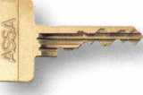

ASSA believes that key control provides the highest level of security. Statistics say

that if 1000 people have duplicate keys to your school’s locks, 100 of those people have

SOME PRESTIGIOUS SCHOOLS ARE  
EASIER TO GET INTO THAN YOU THWK.

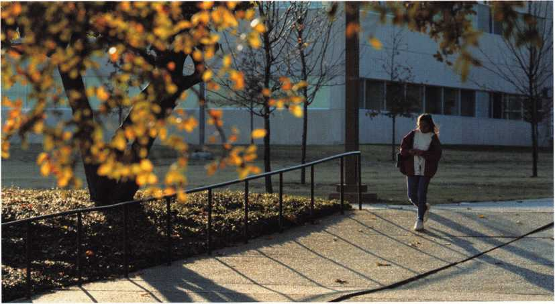

malicious intent. Out of those 100 people, 10 will use the keys / H \ the security

**PYRAMID  
RULE OF**

and break into your school buildings. Of those 10 people, / 10

one will cause serious bodily harm to a victim

ASSA locks can be master-keyed to suit an entire school or a whole school system. Avoid

this “Rule of One,” protect your school buildings with ASSA locks.

ASSA

We Secure The World

an ASSA ABLOY group company

ASSA, Inc., 110 Sargent Drive, New Haven, CT 06511, (800) 235-7482, Fax (800) 892-3256 [www.assalock.com](http://www.assalock.com)  
ASSA Canada, 3475 14th Avenue, Markham, Ontario L3R OH4 Canada

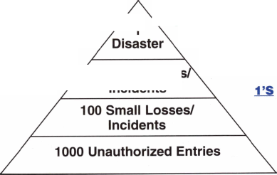

Letters to the Editor

Reaction to the Attack on America

ALOA:

desde Buenos Aires, completamente por lo que ha suce- dido ayer en Washington, New York y Pensilvania, les envio mis mas sentidas condolencias para Uds. colegas cerrajeros y por vuestro intermedio a todos los familiares de las victimas y al pais todo.

Con pesar los saluda, Sergio W. Prieto, ALOA #28391

ENGLISH TRANSLATION

ALOA:

ALOA:

On behalf of the Associated Locksmiths of Ireland, I would like to convey our deepest sympathy on the terrible atrocity which was inflicted on your country yesterday. Like the rest of the world I watched in horror to what occurred in New York, and just like everyone else, I have not got the words to describe how we all feel here in Ireland.

Our thoughts and our prayers are with you.

God Bless you all.

From Buenos Aires: I was completely dismayed by the reason this has happened recently in Washington, New York and Pennsylvania, and I deliver my most deeply felt condolences for you, my colleagues, locksmiths, and by extension, to all the rela­tives of the victims, and to the whole country.

Alan Brown

Editor’s Note:

On behalf of everyone at ALOA, we sincerely thank all of our International friends for their kind words.

With deep felt sorrow, Sergio W. Prieto, ALOA #28391

ALOA,

ANKO company and Latvian Brotherhood of Locksmiths present deepest condolences to all American People because of tradegy of September the 11th.

**Safes In Stock...  
Ready to Ship**

Igor Anshevich,

ANKO Ltd.,

Latvian Brotherhood of Locksmiths

ALOA:

I wish, on behalf of my fellow colleagues on the National Council, Head Office Staff and indeed, all our membership, to send our very deepest sympathy to your country and people. I cannot express in words the feelings and emotions that we are experi­encing in coming to terms with such a terrible crime against innocent people. I assure you that our prayers and thoughts are with you all at this very sad time.

Yours sincerely, Gary Eckersall, National Chairman of the Master Locksmiths Association (England)

amsec FireKing

GariaH hayman

MEIUNK *y/CTO/z*

MORE PROFIT... FREE FREIGHT

TURfll©

WHOLESALE SERVICE

**800-848-9790**

***Our business is helping you sell more safes!***

***Keynotes***

October 2001

**Wear the Ring**

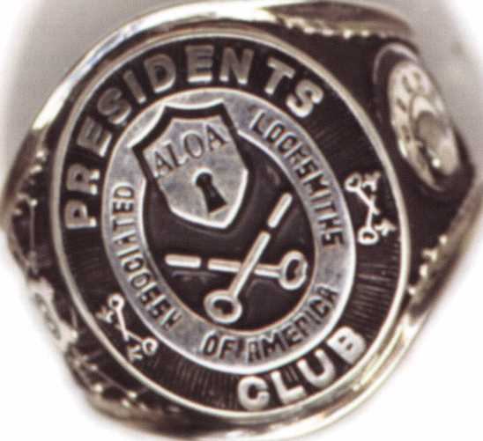

Name Members

Recruited

Kwok-kei Leung 204

Toshihiro Asano 113

Henry W. Raymond 100

Yuriko Yanai 69

Stewart J. Levine CML 66

Mary S. Ohmit CPL 66

Charles C. Robertson CML 65

Jack Hobin CPL 51

William B. Neff CML 48

Salvatore J. Dulcamaro CML 40

Myeong-Rae Cho 38

Dana L. Barnum CML 35

Barry K. Leas CRL 35

C Allan Halverson 32

Danny W. Rudd CPL 31

Larry A. Warnick CML 31

Jeanne G. Lodge CML 30

Breck H. Camp CML 28

William Lee 28

Lawrence F. Smith Jr, CML 27

Anthony J. Ramunno CML, CPS 26 Marian M. Swann CRL 26

James M. Watt CML, CPS 26

Jeffrey S. Nunberg CML, CMS 26

J Thomas Hood CML 26

Jim Williams CRL 26

James H. Glazier Sr, CML 25

Robert F. Carroll CPL 25

Robert H. Stafford CML 25

John C. Elliott Jr, CML, CPS 24

Robert D. DeWeese CML 24

Jerome L. Cohen CML 23

Peter K. Gauthier CPL, CPS 23

Elvis D. Hammerschmidt CPL 23

Man-Soo Seo 23

Diana R. Barnum CRL 22

James J. Cawby CML, CPS 21

Eugene R. Altobella Sr 21

Michael B. Groves 21

Philip A. Rovenolt CPL 20

John L. Shandy CML 19

John S. Dorsey CML 19

D Michael Lee Sr, CPL 19

Robert W. Duman Sr, CML 19

James E. Fowler Sr, CML 18

David C. Harris CML 18

Walter W. Lascar RL 17

Peter R. Hall 17

Thomas G. Vandersteen CML, CPS 17 William P. Grant CRL 17

Keizo TakahashiCRL 17

Evelyn V. Wersonick CML, CPS 16 Joseph P. Ferrero CML 16

Gary F. Teams CPL 16

Kenneth E. Kim CRL 16

Michael E. Jordan Jr, CML 16

Brian J. Reetz 16

Robert C. Rodocker CRL 15

William J. McElheney CML 15

Joseph W. Whitaker CPL 15

Jon B. Griswold CML 15

Michael D. Robinson CRL 15

Russell P. Fuller CRL 15

Daniel L. Landry Jr 15

James L. Hancock CRL 15

James E. Gruber CRL 14

James T. Brickler CRL 14

Joseph C. Fuller CML, CMST 13

Leonard J. Passarello CPL 13

Frank D. Hartung CML 13

Rolando Bouza 13

Paul M. Souber 13

Donald H. Shiles RL 13

John A. Ilk CRL, CPS 13

Richard C. Sievers 13

Ernest W. Wright 12

Raymond C. Lusk CML 12

John F. Engel CRL 12

Eric F. Veal 12

Thomas J. Demont CML, AHC 11 Basil W. Shannon CPL 11

Calvin G. Harris CML 11

Herbert C. Dusenberry CML, CPS 11 Timothy K. Chow 11

Dale L. Knowles CPL 11

Alvin N. Minor 10

Gene EldridgeCPL 10

Ronald P. Riggins CML 10

Lester S. Brodsky 10

Larry L. Votaw CML 10

Thomas R. Smith CPL 10

William T. Straub CML 10

Richard T. Johnson CPL 10

Dale V. Crosby CPL 10

James V. Hawley CRL 10

Eugene R. Altobella Jr 10

James Bright 10

*ALOA Board of Directors not eligi­ble for membership in the President's Club

How can I join the President s Club?

You can earn a membership in this presti­gious club by recruiting just 10 new mem­bers for ALOA.

*Any ALOA member may participate.

What do I get?

When you recruit 10 members, you receive your choice of either a handsome blue blaz­er with a President's Club crest or our new President’s club ring. For each additional five members you recruit, you receive a lapel pin with gold-filled numbers, indicat­ing, your recruiting successes.

You also get the satisifaction of knowing that you are helping your association, help­ing your industry grow, and you are help­ing fellow locksmiths achieve success.

How do I get started?

Contact the ALOA office for a supply of applications (800) 532-ALOA or FAX (214) 827-1810. One President's Club credit is awarded for each new applicant. Credit is awarded only after the membership appli­cation is approved. However, the credit will apply for the period in which the applica­tion is received. Failure to identify yourself as the sponsor on the application form at the time it is submitted to ALOA for pro­cessing will forfeit any credit.

October 2001

***Keynotes***

October is Crime Prevention Month...October is Crime Prevention Month...October is Crime Prevention Month...October is Crin

"Key" Into Crime Prevention

Crime Prevention Month—observed every October - is a nation-  
al celebration and public awareness initiative to recognize and  
build support for actions - personal, neighborhood, and com-  
munity - that prevent crime and make communities safer and  
more vital. It brings together neighborhood groups, civic clubs,  
law enforcement, social service agencies, youth groups, faith  
communities, schools, public health agencies, business groups,  
and all the other elements of communities to learn and take  
steps against crime.

This is a great opportunity for the locksmith /  
security professional to "key" into this nation-  
al effort.

Crime Prevention Month is a key event in the National Citizens’ Crime Prevention Campaign. It is sponsored by the Crime Prevention Coalition of America, with more than 4,500 national, federal, state and local agencies and organizations. The Campaign is best known for that famous canine, McGruff the Crime Dog® and the slogan "Take a Bite Out of Crime.” It is a highly localized event designed to generate and recognize year- round crime prevention efforts and to raise public awareness of the value of personal, neighborhood, and community crime pre­vention action.

Crime prevention, according to the Crime Prevention Coalition and the National Crime Prevention Council, which manages the national campaign, encompasses a wide range of action, includ­ing home security, business security, fraud prevention, child pro­tection, personal (street and driving) safety and much, much more.

An interesting fact: An independent 1993 survey of the impact of public service announcements, produced for the National Citizen’s Crime Prevention Campaign, (featuring McGruff the Crime Dog® and his "Take A Bite Out Of Crime" message) found that 80 percent of the adults surveyed recalled having seen

By Claire L. Cohen, CML

or heard the McGruff ads and nearly one-third said they learned from them. About one-fifth said they had taken specific actions as a result of the public service announcements.

This means that there is a wide range of subjects that security professionals can "key" in on, using their expertise to help edu­cate the public about crime prevention strategies and its value, not just at the personal level, but community-wide.

One excellent way to get started is talk with local law enforce­ment agencies about what they are planning and about what groups might be interested in home and commercial security basics. Be sure you are up-to-date on local laws and regulations on subjects such as the use of double cylinder deadbolts, etc.

**DISPLAYS**

•Set up an area with special signs and displays of products that upgrade residential and business securi­ty. Remind customers that good locks are a key to preventing burglaries, and encourage them to act dur­ing Crime Prevention Month.

* Post a list of local crime prevention groups, if you local law enforcement agency can provide one. Urge customers to get involved to help make their neigh­borhoods safer.
* Display pamphlets on a wide range of crime pre­vention topics, including child protection and teen safety as well as home and personal security and neighborhood and community action ideas.
* Invite a nearby Neighborhood Watch group to recruit new members through your place of business by setting up an information table (perhaps on a weekend).

**BROCHURES & OTHER MATERIALS**

* You can request a Crime Prevention Month Kit by calling 800-627-2911. Via a web site: [www.ncpc.org](http://www.ncpc.org)



Keynotes

October 2001

■evention Month..October is Crime Prevention Month...October is Crime Prevention Month...October is Crime Prevention Month,

(in a PDF format), The National Crime Prevention  
Council (NCPC) offers camera-ready tri-fold brochures  
that cover many different topics.

•These camera-ready sheets (8.5 x 11 inches) fold  
into three-panel brochures that pack a lot of infor-  
mation into a little space. They can be photo-  
copied or printed and set up in a special display to  
help educate your customers.

•NCPC offers numerous publications, most free or  
low-cost, on crime prevention strategies. Call the toll-  
free number to ask for a free catalog, or visit their web-  
site at [www.ncpc.org](http://www.ncpc.org) to view the publications that are  
available.

* Check with your local law enforcement agencies  
  about brochures they may have available.

**NOTE: McGruff is a Non-commercial Dog!**

McGruff, the crime dog, may not be used  
or displayed in connection with specific  
brands or products. He may not be used

rare a hth stir of

CRIME to promote a business or product. Using  
McGruff other than on the reproducible brochures  
requires advance permission from the National Crime  
Prevention Council. Your local law enforcement agen-  
cies may have a McGruff costume and may be willing  
to work with you on a public education event that fea-  
tures the Crime Dog.

**SPECIAL MAILINGS:**

* Consider sending a brochure or checklist to current  
  or prospective customers, reminding them that Crime  
  Prevention Month is a good time to check their home  
  or workplace security. Offer to help.
* Consider an advertising mailer with specials to cele-  
  brate Crime Prevention Month.

**PUBLIC SPEAKING & DEMONSTRATIONS:**

* Work with public agencies and other organizations - - neighborhood-based or community-wide - on solv­ing problems. Offer your assistance to speak to com­munity groups about crime prevention. Let them know that you are a security professional and can offer solutions.
* Build a partnership with police, that focuses on solv­

ing problems instead of reacting to crises. Offer assis­tance in speaking to groups, in conjunction with crime prevention meetings, fairs, or other educational pro­grams.

* Offer to talk about security at shopping malls or clubs. (Clubs are always looking for speakers!) Perhaps the Chamber of Commerce in your area would like you to speak.
* Speak at schools functions, educating children about the importance of their efforts in crime preven­tion (possibly using examples of a lock on their bicycle when unattended, locking doors at home, etc).
* Radio programs may be interested in using a securi­ty professional to talk about security

**LOCAL PUBLICATIONS:**

* Target October for placing ads in conjunction with Crime Prevention Month.
* Write articles for local publications to increase awareness of urgent crime-related issues facing a com­munity and offer security solutions. This will demon­strate a level of community involvement as a profes­sional in the security industry, and may mean extra business for your company.
* If you advertise in local periodicals, show your sup­port during crime prevention month. "XXX Lock / Security Company supports Crime Prevention Month.”

Public education about crime prevention requires conveying pos­itive messages to the public. Lay the groundwork for the long­term behavior and attitude changes that will help make crime prevention a way of life in your community Get involved. Volunteer to help in community and neighborhood anti-crime and other community improvement efforts. Encourage groups you belong to - religious, civic, social - to help stop crime.

With proper planning, you can promote your business and help your community with your efforts during October—"Crime Prevention Month.” If it’s too late this year, perhaps you can start your planning now to make next year’s National Citizen’s Crime Prevention Campaign a success for you, your company and your community!



October 2001

***Keynotes***

...October is Crime Prevention Month...October is Crime Prevention Month...October is Crime Prevention Month...October is Crim

Crime Prevention

and the

Security Professional

By Jim Hancock, CRL

Crime prevention. Play word association with these two words and I can almost guarantee you that the list of associ­ated words will not include "locksmith." Crime prevention will usually illicit words like police, alarms, guns, dogs, virtually everything but locksmith. We cannot fault the average person for this failure to recognize our industry, we must first blame ourselves. The way our industry has been portrayed for decades, the image some of our less than professional brethren create by their manner and dress, the yellow page ads, the "discount store" undercut pricing, have all contributed to our almost invis­ibility when it comes to security. Most people believe us, as an industry, to be ex-cons who learned our "trade" the wrong way or tinkerers who fell into this line of work. The image is gener­ally the guy working in the shed in his back yard wearing over­alls that makes keys, sharpens saws and generally does "handy­man" type things. This is not a swipe at handymen, but our business is so much more diverse and is no longer a "trade," but is more a profession.

It is hard to get the general public to look upon us any other way until we get everyone in our profession to look upon ourselves in a different light. Let's look for a moment at the pro­fession, law enforcement, that is generally the first one thought of in reference to crime prevention and is really the second line of defense behind us. The first difference is training. As a prospective law enforcement officer, you are put through an

intensive training program to learn the rights and wrongs of the criminal justice system. They are constantly sent to continuing education programs to enhance their knowledge and skills. As a prospective locksmith, you aren't required to go through any training per se. If you can read, if you have a computer, if you have a little extra money, there are any number of places via mail or Internet that profess to be able to train you in locksmithing. All of you have seen the ads on television with the well known actress showing you how you can get your GED or a degree in any number of trades including locksmithing. I take nothing away from some places that have been doing training for years and years through correspondence classes, but all of us in this business know there is no replacing hands on, live instruction or On-Job Training through a qualified locksmith. And continuing education is an option not a requirement. We all know a lock­smith somewhere who will say that "classes are a waste of time," "I'll never work on those," "I know all I want/need to know."

How about dress? I have never seen a policeman, not counting undercover officers, who were not in an identifiable uniform or manner of dress. Patrol officers are always in uniform with identification, name tags, on their shirts so they are readily identifiable. Most detectives are generally in suits or jackets and ties with their badge readily displayed on their belts or on a lan­yard around their necks. What about us? How many of our fel­low locksmiths have you seen in tattered jeans and a tee shirt or

Keynotes

October 2001

evention Month..October is Crime Prevention Month...October is Crime Prevention Month...October is Crime Prevention Month.

worn, unwashed looking clothing of some sort. And no name tag or any identification whatsoever save for the signage on the vehi­cle and sometimes that doesn't exist. Yes, this is the person I'm calling for crime prevention!

Advertising. This is also a place where we, as an indus­try, have helped perpetuate the image that has existed for years. "Keys made, cars opened, locks changed.” All valid parts of our business but is this really the focus of our industry now? How about using new buzzwords such as "High Security, Access Control, Key Control." These can be used in reference to hard­ware sales and services rendered. We will always duplicate keys and rekey locks but so does your local discount store and hard­ware outlet. What sets us apart from them is the ability to do more for the customer in regards to their security and the serv­ice before, during and after the sale. A customer may be able to buy and have locks rekeyed at their local Do-It-Yourself hardware giant but what about installation of the hardware? Or service on the lock when it fails?

What about pricing? Have you ever had lawyers or doc­tors haggle over pricing with you? Probably not. They have a set range of fees that are charged based on what the market will bear. You choose your lawyer or doctor based on other things besides pricing. You choose them based on bedside manner, honesty, how much they overbook, how readily available they are when you need them, etc. Should we be any different? Customers should be able to choose us based on our availability, our service, our honesty, not because someone will rekey an entire house of 5 locks with 10 keys for $25 while the rest of us are trying to charge a fair rate and make a living. Doctors and lawyers charge based on what they know, not necessarily what they do. They charge based on the amount of time spent learn­ing their profession and keeping up with the latest legal findings, codes, medicines, techniques. Should we be any different? We must constantly update our equipment and knowledge because of the ever-changing technology of our industry. We may be able to unlock a car in a matter of seconds, but the fee is based on the knowledge of how to open that vehicle as well as the tools we must have.

This brings us back to crime prevention. This brings us to a point where we must change the general public’s opinion of our profession and in order to do so, we must change our own thinking. Locksmithing and locksmiths, though a time-honored business, are very outdated terms. The more appropriate title

for our business should be “Security Center” and the technicians “Security Professionals.” We now have to know so much more than how to duplicate a simple key and rekey a common lock. We now have to keep up with changing legalities such as ADA and NFPA Life Safety Codes. We need to be able to listen to a customer’s "symptoms" and develop or "prescribe" a cure. We need to not only rekey a customers lock’s when they have lost or misplaced keys, but be able to recognize other shortcomings in their overall security and recommend solutions, whether or not those solutions are something we ourselves can do. We need to charge a fair rate for our services and be able to morally and eth­ically walk away feeling good about the service and the charge. We need to recognize when a job is too large for our company or is beyond our expertise and be willing to miss the sale in order to assure the customers safety and security is not compromised by our shortcomings. We must be proud of our profession and show this pride by looking like a professional and not someone that just spent the last 8 to 10 years learning our craft at the State's expense, if you know what I mean.

We need to better educate those people just beginning in our business in fundamentals and sound business practices.

We need to further the education of those journeymen in our business so that aren't left behind or using antiquated methods and ideologies. We need to revere those elders in our business and tap every resource they are willing to share while they are with us.

Crime prevention begins with us, the security profes­sionals. Every time someone calls you to rekey a lock, repair a lock, or install a lock, their physical safety and security is in your hands. Word association is not just a game or psycho-babble; its how the majority of people make a first contact with someone who performs a service they have never or rarely used. Ask 5 of your existing customers to tell you who they would call if they wanted to speak to someone about crime prevention and you may get 5 different answers and almost guaranteed none of these answers will be you. We must promote our image of profession­alism. We must understand that this is not simply a job and we are not just trying to earn a buck, but rather we are the first line of defense in the security and safety of person or property. We must truly like helping people solve a problem; the money will follow.

Crime prevention...Security professional...that's a great association.

***Keynotes*** 117

October 2001



October is Crime Prevention Month...October is Crime Prevention Month...October is Crime Prevention Month...October

“‘Foiling the Smash

CR1M

**and-Grabbers**

A New Slant on Securing Windows

There's no denying the aesthetic value glass windows and doors give a home or commercial building. But is glass really the best defense for your family, co-workers and personal property when danger looms outside? The new Scotchshield from 3M is a tear- and penetration-resistant security window film that withstands 400 pounds of pressure and is only 4 millimeters thick while con­sisting of 26 microlayers. It is the 26 microlayers compressed into 4 mils that makes this film unique.

To locksmithing businesses trying to deliver security solutions to customers, Scotchshield represents an affordable, effective deter­rent to smash-and-grab burglars. What better month to sell them on the idea than October - Crime Prevention Month?

This film also helps hold your glass in place during hurricanes, tornadoes, earthquakes, even bomb blasts and other explosions. It helps reduce damage and injury from indoor incidents like chil­dren running into or throwing things at glass doors or windows.

The film is tested and retested to exceed industry standards and is fashioned out of an exceptionally tough polyester. It is secured to the inside of windows with an aggressive adhesive system, which holds the glass together. And even though its main job is

By Jim DeSimone, Editor

protection, this material also helps alleviate "sun control" prob­lems. Some of the 3M window films can help by blocking out heat that would otherwise pass through the window, saving precious funds in energy costs.

The film can also be made to reduce glare, causing less fatigue for people who normally have to squint and strain to view TV and computer screens on bright days. It can also block up to 99 per­cent of UV rays, which can fade fabric, flooring, wallpaper and other valuables. The tinted films can add an extra degree of pri­vacy, if desired, and the upkeep on this product is virtually nil. Simply clean your windows as you normally would. The lifetime warranty against cracking, fading, blistering, bubbling, discoloring or delaminating doesn't hurt, either.

For residential applications, the film costs between $7 and $8 per square foot, a price that includes installation by a 3M dealer. This film may not be for everyone, but it does offer your customers an alternative to other methods of securing their windows. For more information on how you can distribute 3M window film to your customers, contact 3M's Tom DeRosa at 800/940-9142.

181

Keynotes

October 2001

**23rd Annual**

**Yankee Security Conference November 7-11, 2001**

**STURBRIDGE HOST HOTEL, STURBRIDGE, MA**

**10 comprehensive and innovative classes ALOA, A.C.E. certified instructors**

**2-day trade show event with the industry’s top manufacturers, distributors and manufacturers’ representatives**

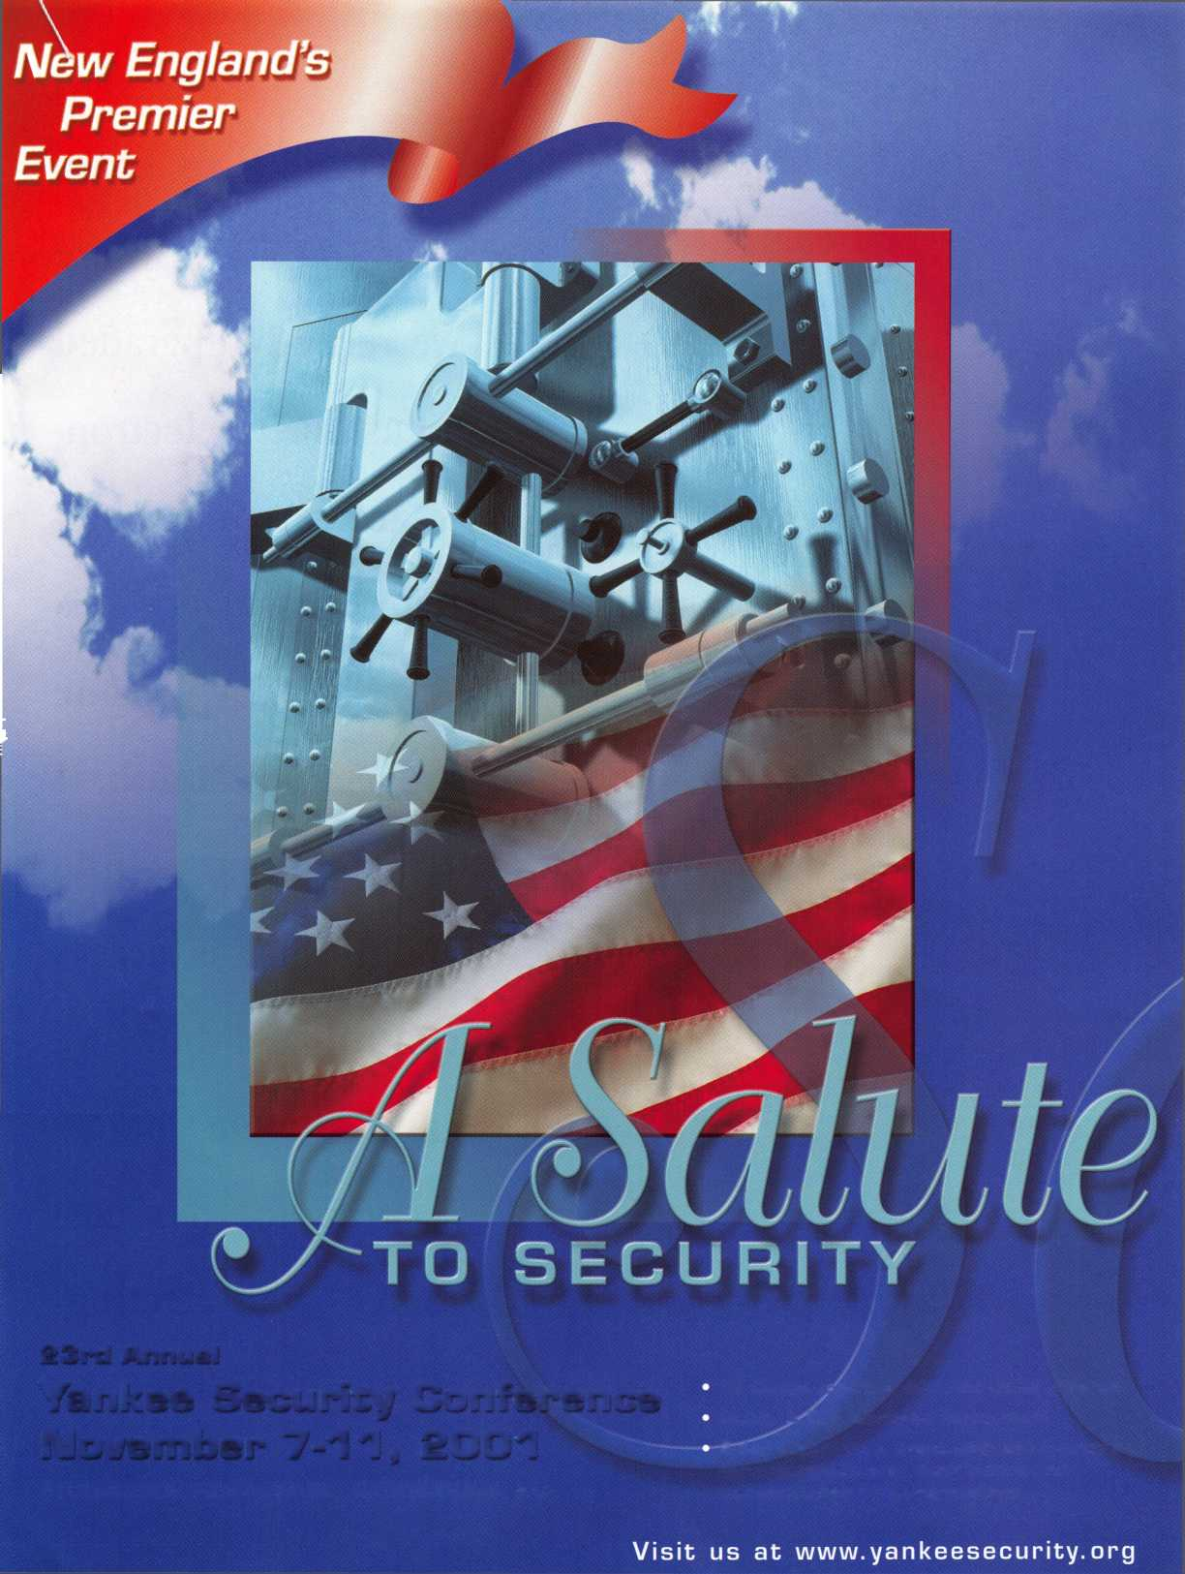

**I'd like to share with you a job where we recently upgraded a customers electron­ic access control sys­tem. First, since this is National Crime Prevention Month, I want to discuss a little about what is access control and how we can provide better security for our cus­tomers with electron­ic access control.**



Keynotes

October 2001

Access control comes in many forms from a simple rope draped across an opening to full blown electronic systems with biometric iris-scan readers, alarms, high security locks, and guards. Anything that prevents or alters access to an area may be considered access control. These days, your customers ask for more security or where you see a need for more restric­tions or benefits then a mechanical lock alone can provide. It may be time to step into the world of electronic access control. A simple and common electric access control is a keyed doorknob with an electric strike and a momentary push button inside the restricted area to energize the strike, allowing the door to be opened. The next step up is to provide some form (either a keypad or a reader) next to the door to grant access. The most elaborate systems still require some form of a lock, like an electo-magnet or a mechanical lock, to keep the door closed. The system only acts as the on/off switch. Some of the advantages to electronic systems are as follows. The ability to limit individual or group access to certain hours and/or days. Master keying and group keying may be provided without the mechanical disadvantages such as interchange or decreased pick resistance. It is very easy to add or remove individual cards or "keys.” Tracking of the time access has been granted or denied to an individual and if desired, the time they leave, is easily provided. A door can be set to lock or unlock at certain times automatically. With the appropriate hardware like a turnstile "tailgat­ing" or having multiple people enter at one time can be reduced or elimi­nated. In all cases the electronic access control adds to the physical hard­ware, which secures the door.

This job started with a simple request; "Make their door lock.” The existing access controller was supplying power to electric strike continu­ously no matter what they did. The company that supplied the equipment was willing to look at the problem for a large fee provided they also upgrade to the newest software. It seems they no longer support the old software. The customer was a little upset since they just upgraded a couple of years ago. I took a look at the software and controller. The computer said the door was locked or not energized, so we tried unlocking the door with the computer. The door was still unlocked. No matter which setting we used the electric strike was still energized. They asked me for a quote to replace the controller with something else. They also asked for a temporary fix. I added an on/off toggle switch in the wire going to the strike. This would allow them to turn the switch on during the day (when the door would nor­mally be unlocked) and off at night. This sufficed until I could verify the existing cards as readable by a Kantech reader and that we could integrate

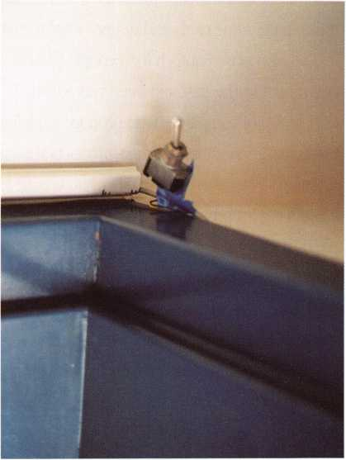

Photo 1

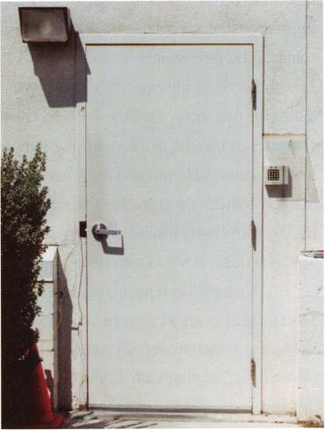

Photo 2

October 2001

***Keynotes*** L_

our system with the existing cards since they also have a time clock system utilizing the same cards and did not want to change.

I choose Kantech for a couple of reasons. First we have used their equipment in the past and been very satisfied. They are also a part of the DSC group of companies who produce a quality product and, more impor­tantly, have stood behind their products the couple of times I have had a problem. They also offer excellent no charge tech support. They offer a custom reader program to read many different card formats. I took a cou­ple of their cards and sent them off to our Kantech supplier to verify, as I suspected the magnetic stripe was an ABA (American Banking Association) standard. This is the same type of magnetic stripe on the back of credit cards, ATM cards, California drivers licenses, even the pizza joint down the street uses an ABA standard card for their pizza club. A couple of days later the supplier called with the good news. They could read the card. I pro­vided the customer with a quote to replace the controller and reader at the door. I also included a second reader to be placed next to the computer. This would allow them to enroll cards in the office where the computer was sitting instead of having to go out to the door each time they wanted to add a card. The person I was dealing with would have to take my quote to upper management. Our quote was over three times the cost of the software upgrade for the existing equipment. I was a little concerned, but they want­ed local service. I felt a quality system and local service would outweigh the extra expense. I was right. A week later they called with the OK, how quick could I install the system?

I ordered the equipment and scheduled some time for the install during the next week. Over the weekend I downloaded the software to my computer to become familiar with the software before going to the cus­tomers location. I've installed many brands of equipment and used lots of different software programs but this would be my first install of a Kantech KT200 control using WinPass software. A functional demo copy of the soft­ware is available at [www.kantech.com](http://www.kantech.com).

We started by replacing the wire running from the door to the com­puter room. Plenum wire was used since we would be going through a drop ceiling that is used by the air conditioning system as a return air duct. We followed the existing path from the door using the "Wiremold" they installed. I decided to move the reader to the lock side of the door. The original reader was installed on the hinge side. This was a safety issue; this door does not have a vision light or window. Each time you read your card, you needed to walk back across the path of the door and several employees

221 ***Keynotes***

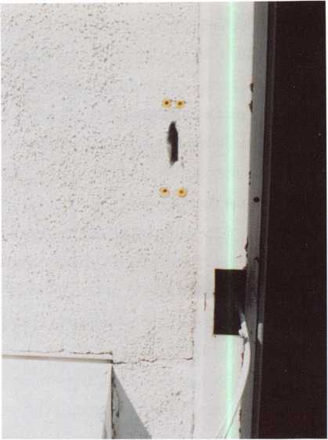

Photo 3

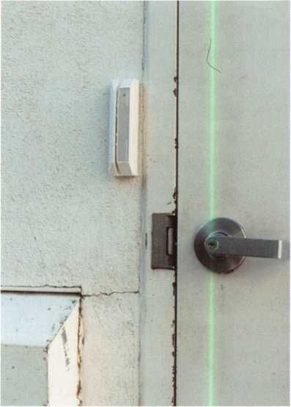

Photo 4

October 200 **7**

were hit with the door by an exiting employee. Moving it to the lock side would reduce chances of this happening. Next I removed the electric strike and cut a hole in the wall next to and slightly above the strike cutout for our reader. The wires were connected to the strike and since the old system used a 12 VDC and Kantech provides a 24VDC output the solenoid on the Folger Adams strike was replaced with the appropriate one. Next we needed to run the wires from the drop ceiling on the first floor to the computer room on the second floor. We locat­ed an abandoned telephone cable and used it as our pull into the second floor. We mounted the control box over the top of the old telephone cable entry. We also ran a second power cable into the drop ceiling below where 120 volt power was available for the wires in the transformer. A second reader cable and the flat 6-conductor cable were stapled along the surface of the wall to the computer and a reader was mounted to an electrical box for a tidier look. This second reader is available to add cards to the system without having to go to the door each time they wanted to add a card. All the wires were connected to the appro­priate places in the control and we powered the system up. Next we installed the software. WinPass software from Kantech offers

an express setup similar to “plug and play.” I offered a pray and started the setup program. Unfortunately the computer didn't connect or communicate with the controller. I rechecked the wiring and tried again. It still did not connect-time for lunch. Sometimes walking away from a problem and coming back to it later will work. After lunch I thought I'd found the problem, I needed to reset the readers to the appropriate type of card. I reset them with no luck. Time to call tech support. They walked me through a couple of steps in setting the dipswitches in the controller to the appropriate settings and we were up and func­tioning. Now its time to program the schedules and add the cards into the database. I added a few cards and checked them at the door. They worked. It's a great feeling when almost everything goes as planned and the system functions as we advertised.

Electronic access control is profitable. Behind safe opening we charge more per hour for it than any other type of lock work we do. It takes some training, an understanding of electricity, building codes and some wire running or hiding skills, but once mastered it can add nicely to your bottom line.

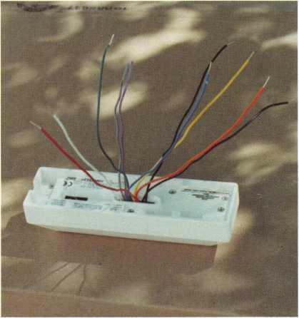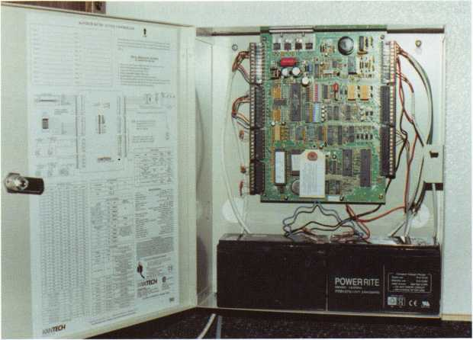

Photo 5

Photo 6

October 2001

***Keynotes***

That’s right! It is a university that has different colleges that cover different professional disciplines. What, you have never considered that your profession of security has different disciplines? For many years the average locksmith has been nothing more that just a locksmith. One goes along without realizing just how much knowledge is contained in the individ­ual driving that service van to the next appointment or emer­gency. There is no such thing as "just a locksmith" not if we’re talking about professionals.

As a business matures, time passes and a reputation is built and employees are hired. Each employee as they learn the business of locksmithing finds a niche. They find that one spe­cial thing that allows them to make a unique contribution to the business structure. This is generally realized in specializing in a particular aspect or discipline within the focus of security. It may be that the employee becomes a vehicle guru or a "safe cracker" or a masterkeying wizard. It doesn’t matter what the particular field of expertise it may be; the employee simply becomes an expert and therefore, a professional.

FireKing has under its control a wide range of prod­ucts for the security professional to work with. There are safes from the Meilink®, Gary®, and NKL® product lines. There is the renowned FireKing® insulated file cabinet product line.

University

By Donald B. Dennis, CPL

Along with this are the Image Vault® products with digital video surveillance capabilities and the Entera™ Security Doors. There are just too many products and too many disciplines to cover everything under one single classroom situation. This is why the university and college breakdown has evolved.

The university is FireKing University. The colleges are the Safe, Digital Video, Door Security, and Files. They are all of varying lengths but generally two full days of instruction will cover the most intensive course of study within a single disci­pline. The university is located within the FireKing factory at New Albany, Indiana. This is important since you will receive the instructional materials as well as having the opportunity for a hands-on experience. The big plus of having the classes at the factory, with all of its activity, is that it allows you the under­standing of how your future orders will take place and how the assembly of the product that you will be working with in the field is actually produced. On top of this already special expe­rience, you get to know the people involved with the products, developing that special rapport between yourself and the facto­ry for support in your future dealings. This would, of course, mean a factory tour in order to complete your understanding of what goes into the product.

I was very impressed with my visit to the FireKing facil-

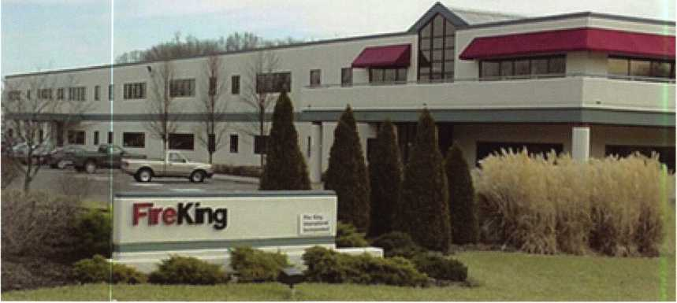

**FireKing® factory and headquarters in New Albany, Indiana. The Meilink factory is just across the parking lot!**

Keynotes

October 2001



ity. Impressed by witnessing the efforts to provide not only quality products but also in the comprehensive character of the education. It might be natural for any locksmith or secu­rity professional reading this to react by stating that this is just another effort for a company to rise above the others and that there is already enough known about the product line, so why bother? Well, to help you zero in quickly to your special niche the balance of this article is broken down by colleges. Before I do that, however, I should mention that each class is unique by those in attendance. The instructor will focus even further by the details that the class members bring up during the instructional and hands-on sessions. This makes each class unique requiring high participation from the students.

I know that there are also those small but important details that every student would ask. I asked them too. To my knowledge the classes are still a low $195.00 a day per student. Yes, you do get to take home the manuals. Yes, this does place you in a position for factory referrals. Yes, class size is limited. One of the best solutions for the making of a class is to get your own group together from friends that you have within the industry. Of course, if that is not possible or if you want to sneak one in on your competition, the factory will take your name and set you up with a class. Oh yes, there is a cer­tification diploma for the effort and money. Your factory con­tact would be Lance Ponder, at 812-948-8400 ext. 697 or 1-800- 457-2424 ext. 697 or e-mail [lancep@fireking.com](mailto:lancep@fireking.com). There is also a web site where you can get the class dates and more information at [www.fireking.com](http://www.fireking.com). Now let me show you a lit­

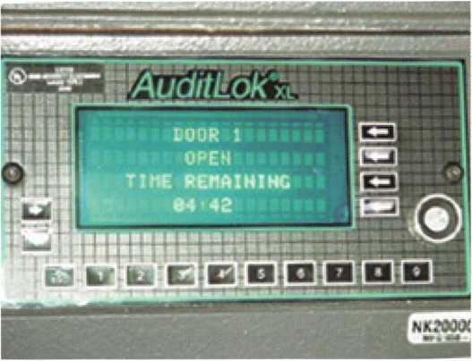

tle bit about the colleges. Oh, yes! Should you be attending the ALOA convention in Baltimore this summer, go by and shake hands with the folks at the FireKing booth! They’ll be glad to see you.

Safe College

I know you are thinking a safe is a safe is a safe! Whoa, friend! Not so fast! This is not true! The Safe College is a two-day course where Meilink, Gary, and NKL are explored, dissected, and critiqued. This course is also a com­prehensive effort to help the student to understand the tech­nical needs of the Autobank safes and their locking devices. This means that you will be exposed to the Audit Verification Lock (AVL) and also the state-of-the-art package of the AuditLok XLV on the new line of NKL Autobank and Intellisafe models. Yes, this would also include the AuditLok XL, which is today’s most popular and best selling cash-handling elec­tronic package within the NKL product line.

All of these fancy names do fancy things. This course will give you some of the basics such as mechanical combina­tion lock diagnostics and UL rating and insurance require­ments. At one time this was the extent of the safe business and now it is but the basics! You will look at all of the differ­ent safe models in the FireKing umbrella and understand the construction of a safe and how it works. In the area of keypad systems, you will investigate LaGard, S&G, and AVL. This will include troubleshooting. You will work primarily with Gary Autobank, the AuditLok XL package as well as the sophisticat­ed AuditLok XLV system. Supplemental information on the

TimeLok XL, the SherLock, and Vindicator packages are pro­vided in the textbook. It is almost unbelievable for me to think that there are safes that can talk to a central programming unit and tell all that has happen to that particular safe since its last report. By the time you finish this course not only will you become a believer but you will see how the safes can use modem technology to send this information to a corporate headquarters anywhere in the world. It is the age of informa­tion and accounting information helps in controlling the health of a company. Therefore, this information is of great importance and translates to dollars for the maker, installer, and caretaker of such high tech materials. You see, a safe is no longer just a safe!

**AuditLok XL is just one of the several packages learned about in the Safe College course.**

October 2001

***Keynotes***

**Digital Video College**

This entire course is based around the Image Vault® tools that are being distributed by FireKing®. This is a one-day course that will cover the sales, setup, and programming of the digital video security tools. You will need your own laptop.

I am sure that most of us have some clue as to how a video surveillance camera system works. We are aware of a camera or system of cameras that will give a live monitor a pic­ture as to what is happening on a premise. Along with that is usually a video-recording (VCR) machine that keeps an ongoing tape of the events as well. While this sort of system works there are a number of drawbacks.

The videotape itself is vulnerable. There is tape degra­dation over time. Storage space for tapes is also a major con­cern. Reusing older tapes frequently causes system failures to occur because the tape breaks or the degradation becomes so sever that a plausible picture with any real integrity is impossi­ble. The Image Vault system solves these problems while giv­ing us many more benefits with the use of new technology in the form of a DVR (digital video recorder).

Let’s take a real quick look at some of the other advan­tages to digital recording. Generally when we want to see what has just taken place with a VCR system we must stop every­thing. Shut down the system and rewind the tape and take a look. Once the look is over then everything gets turned back on and it is on with the show. Fine except for the down time, right? Well, with an Image Vault DVR this doesn’t have to hap­pen. Mind you that some DVR systems still do have to come to a halt in order to view stored images! It is really this multifunc­tional capability that lies as the heart of this entire matter.

Next is the ability of Image Vault to download its video and data information to external locations via modem, network or even over the Internet. Besides viewing remotely, it is also critical to be able to copy stored events to removable media. In the case of Image Vault, this is accomplished by one button and common ZIP disk. Even while the surveillance by Image Vault is still taking place, you can view recorded material either by a monitor on site or anywhere you have a phone or network con­nection. You never lose any surveillance time at all! Yet anoth­er advantage is the search capability of an Image Vault DVR sys­tem. Internally detected motion, external alarm closures, and point-of-sale data can be programmed as recording triggers. These triggers may also be used to create audit trail entries for

easy searching, and even include options for audio recording, pre-event and post-event recording, and numerous other options. The search can take place using these triggers to take those viewing the monitors right to the event! In a system used to capture point-of-sale data, you can even search the data directly to find voids, drive offs, high-dollar transactions, or any­thing else that might appear on the register receipt.

With Image Vault’s digital technology there is less equipment involved. You can remove the old video multiplex­ers, the video switchers, and the time lapse VCR’s! Image Vault has that built into its box and again, so much more. The IVPLAY software is user friendly and yes, there are several levels of secu­rity from viewing only to full access. Also recognize that there are not any mechanical parts to fail which means no daily labor costs or service costs are involved like with that of VCR systems. An easily searchable database and built-in interfaces are beauti­ful things and high on the list of most sought after system advantages in today’s market place!

All of this just barely scratches the surface of this system’s capa­bilities. If you are looking to expand your business, this area of security may offer you an answer. This college is for all securi­ty professionals including loss prevention individuals.

**Door College**

This training module will educate you on the ins and outs of the Entera Security Door. There are two basic designs being that of all metal construction or metal and glass. The Entera is composed of a frame, door, and door closer, along with hinges and exit hardware. The frame is 14-gage steel and houses the 16-gage metal door. The Entera Door is terrific as a replacement component for old dilapidated back doors for businesses. You know the kind of job site! The front of the shopping center is aluminum glass doors with a concourse of business concerns all in a row. The back is like an alley with a slew of metal back doors with the name of each business scratched on the door face with a black ink felt-tip pin. These doors are abused by the employees and delivery people as trash and packages move in and out of the premise. This course will explain the Entera Door system from its composition to its application.

You will learn about panic hardware and keyless entry packages available with a door or as an upgrade to an existing security. The keyless packages used are Sur-Lock and Adams Rite. The keypads are Essex KP-26 and KP-34. There will also be

Keynotes

October 2001

an explanation of wireless applications using Linear Corporation products. Should your job require basic exit hardware without an alarm then the Arrow exit device is offered. Sur-Lock and Arm-A-Dor offer high security panic hardware with or without alarm. What you will have delivered from the factory is a packaged door and frame completely assembled with all components already installed so that you can simply set it into your application. There may be times where you will not feel comfortable with doing the labor of setting a door and jamb into an application. When this hap­pens, simply set it all up with a subcontractor doing the work for you. However you handle the job, it is pretty nice to be able to accept such a challenge with FireKing’s help in solving your customer’s security problem. It is a much better way than turning it over to someone else in town, possibly losing future sales in security.

File College

The last college that I need to mention is the File Cabinet course that is being offered. This informative course will cover fire resistant files as well as some of the unique items that Fire King manufactures such as the Media Vault, the Transformer, and Safe-In-A-File.

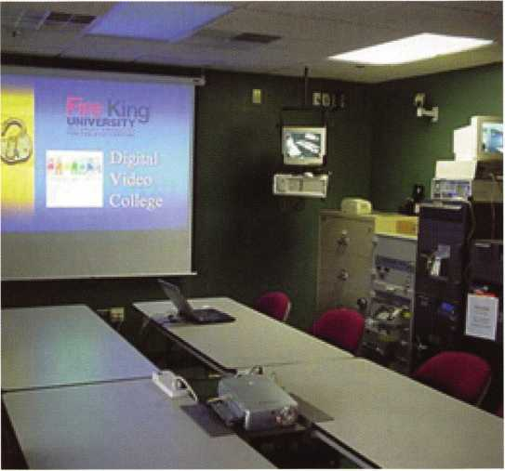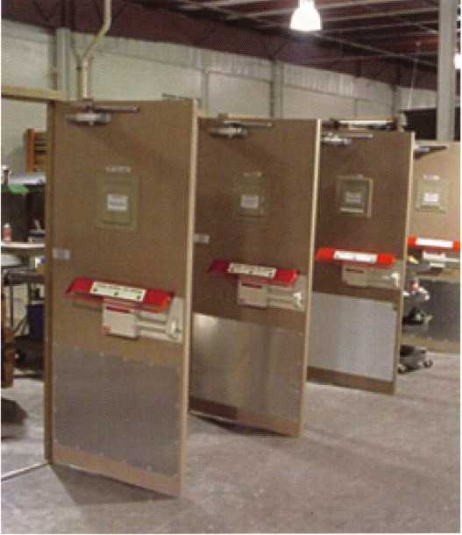

**The factory tour will take you to the area where the Entera Doors are assembled.**

Conclusion

These courses (colleges) that FireKing is offering will help to simplify the security needs of our ever-changing world by building your knowledge of product and application. You will be providing security solutions to your customer while providing yourself business success. You are also being encouraged to join a team that will help your business to secure that future. That team is you and FireKing, all the way to the bank!

**A FireKing® classroom;  
walls lined with safes, files, doors, and  
Image Vault materials.**

October 2001

***Keynotes***

Judging from the call, this

Opening

a

1991  
Pontiac  
Grand Prix  
Trunk

**By Ken Holmlund, CRL**

was going to be just another can't open the trunk of a GM car. The key worked fine yesterday but, today, it won't turn. We had another key cut but it still won't open. How much is this going to cost? You know the routine.

After a few questions, they agreed to bring the car by and I would fix it. No big deal. I have fixed a hundred just like it. Mistake number two. Number one was not asking the right question-have you worked on the lock yourself?

Keynotes

October 2001

When the vehicle arrived, I found the trunk lock had been drilled and removed, see photo 1. Why couldn't they have opened it with a screwdriver I wondered to myself? I stuck the tool into the hole and, much to my surprise, found nothing behind the lock. I put a light to the hole and could see nothing was there. Where is the latch? The owner assured me it was directly below the "key thing.” Mistake number three-thinking he knew what he was talking about.

As I moved the light around, I could see a bolt just to the left of the hole and with a probe I could find the body of something about the size of the latch. If indeed this were the location of the mechanism, how would I proceed to get it opened?

A quick glance at a similar vehicle told me it could be opened through a small opening in the body of the latch, but where was the hole in this vehicle?

I measured the distance from the hole in the body to the approximate location of the center of the latch and allowed a little extra for the hole in the latch to be off center. The meas­

urement was about 41/2 inches. I took and old car opening tool and made a new tool with a 90 degree bend and then 41/2 inch­es from there another 90 degree bend. See photo 2.

With the information at hand, I felt I would be able to hit the hole and open the trunk, but, I didn't count on the hole being so far below center and the fishing expedition took longer than expected. Maybe by luck or the law of averages being in my favor, I hit the correct spot and the truck popped open.

The location of the lock to the hole in the lid of the trunk can be seen in photo 3. The tool placed in the opening of the latch can be seen in photo 4. Of course, the trunk was open by this time and locating the hole was much easier. It is about 3/4 inch below center of the hole in the lid of the trunk.

Upon opening the trunk, I found a cable hanging loose from the latch. By rights, I should have been able to place a screwdriver into the hole in the end of the cable where it attach­es to the lock body and turn it, opening the trunk. When I turned the tool, nothing happened. Further inspection revealed that whomever had tried to drill the lock out had drilled too

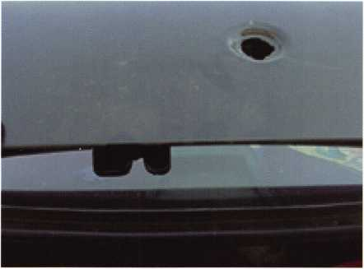

Photo 1

I found the trunk lock had been drilled and

removed.

Photo 2

I took an old car opening tool and made a new tool with a 90 degree bend and then 4 1/2 inches from there another 90 degree bend.

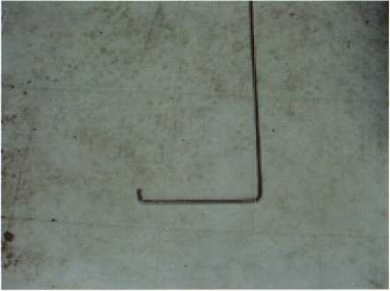

October 200**7**

***Keynotes***

deeply and had cut the connecting wire from the cable to the latch. No repair was possible, and I did not have the part to replace it.

A quick trip to the local Pontiac dealer got me nowhere. They did not have it either and since it was Friday afternoon, they could not have it for me before Tuesday. What could I do? I ordered the part and told the customer he would have to wait until Tuesday to get it fixed. OK with him and a time was set to do the job.

The parts came in as promised and they were even the correct ones. Of course, the trunk was locked when he arrived for the repairs, but, now I had the tool and the opening was quick and easy.

The end of the cable that hooks to the latch can be seen in photo 5. How it is attached is shown in photo 6. Yes, it does stick out from the back of the latch. It fits into a recess in the trunk body and is held in place with two small ears that go through the latch body. They are the shorter protrusion seen in

photo 5. The latch in place is seen in photo 7. The cable is shown hooked to the end of the cylinder in photo 8. I rekeyed the new trunk cylinder to the customer's key. It used the regu­lar GM wafer tumblers

Although the body of the cylinder is very much like the typical GM trunk lock, the plug is very different. See photo 9 for a look at both parts. The part numbers for the cylinder at Strattec 700736 in black, GM 1250555 in black and I did not find a number for BWD. The cable assembly is GM purchase only and is number 10282706. I don't think I will stock the cable assem­bly but I sure will have the cylinder on hand. It seems to have the same loose cap problem as the other GM trunk locks and I am sure I will be seeing more of them in the future.

Working on automobiles can be frustrating but lucrative and as I always say, "I'd rather be lucky than good, but a little education certainly helps add to the luck" Until next time, keep on learning and share your experiences with others in the pro­fession.

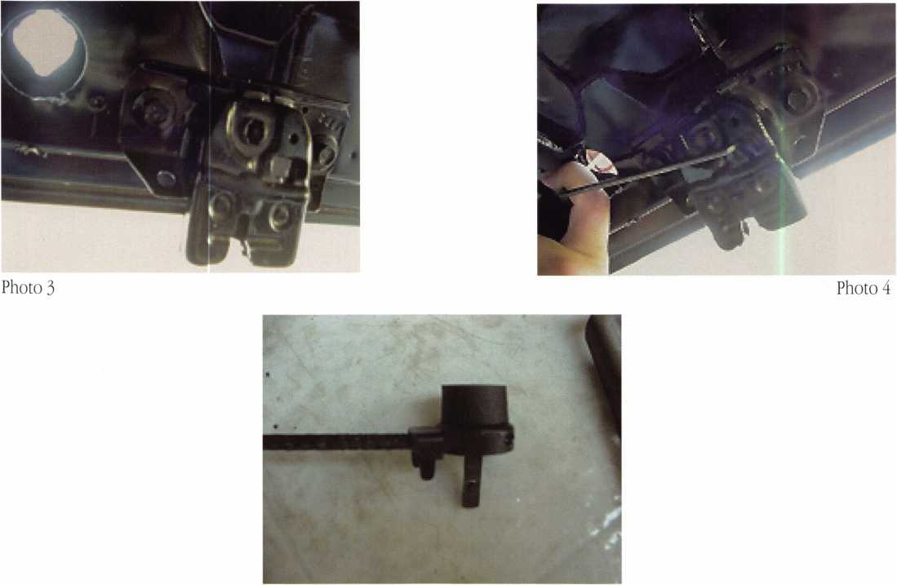

Photo 5

Keynotes

October 2001

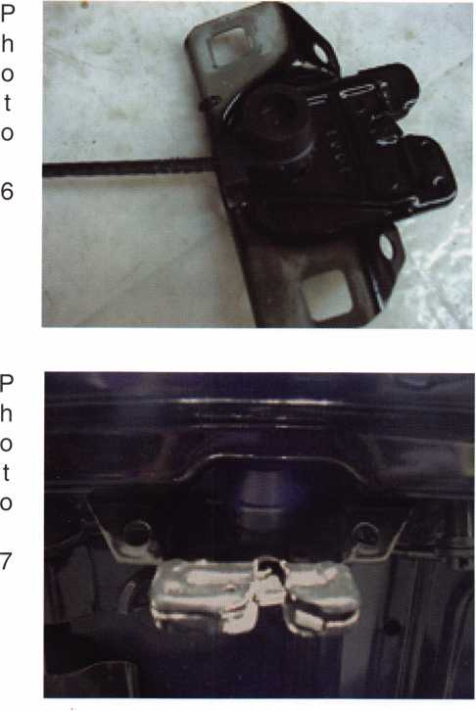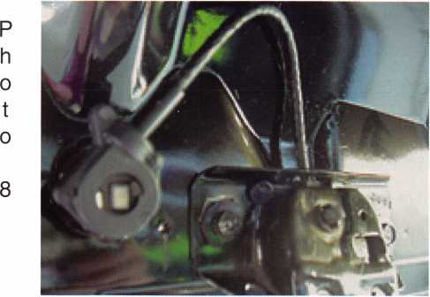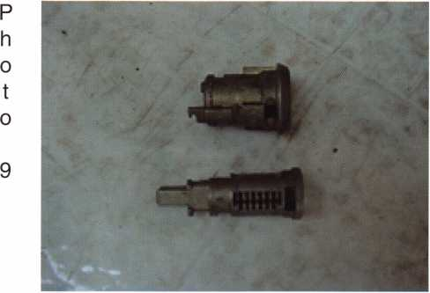

INTERCHANGEABLE CORE PRODUCTS

**SECURITY**

Interchangeable

with:

•BEST

* ARROW
* FALCON

Quality • Price KILLEEN SECURITY Delivery PRODUCTS

That’s what KSP is all about!

Ask your wholesaler about  
our drop shipping.

*33 Hermon St.  
Worcester,* M*!A 01610  
Phone (500) 798-3200  
Fax (508) 753-2183*

Oust a c fief away fromyour

security door hardware needs:

[www.jlmwholesale.com](http://www.jlmwholesale.com)

HJefsite features:

Detailed product information.  
Search capabilities on each page.  
Check box to display only in stock items.  
New quick links. Extremely user friendly.  
Downloadable interactive product catalog.

WHOLESALE /km

DOUR HARDWARE FOR THE MEW Mi

Oxford, Ml 1-800-522-2940 * Charlotte, NC 1-800-768-6050 *

[www.jlmwholesale.com](http://www.jlmwholesale.com)

Order Online -  
Qet 'Tree 'Trmfa!

ADAMS RITE • ALARM LOCK • ALTRONIX • OYNALOCK • ELK • ESSEX ELECTRONICS * FOLGER ADAM SECURITY * GLYNN JOHNSON  
H.E.S. ♦ i.E.L • LCN CLOSERS • LOCKNETICS SECURITY ENGINEERING INC. • ROTON • SOILAGE • SECURAKEY • SECURITRON  
SECURITY DOOR CONTROLS • SELECT PRODUCTS • SIMPLEX • SIGNAL CABLE • TRIMEC • TRINE • VON DUPRIN

October 2001

***Keynotes***

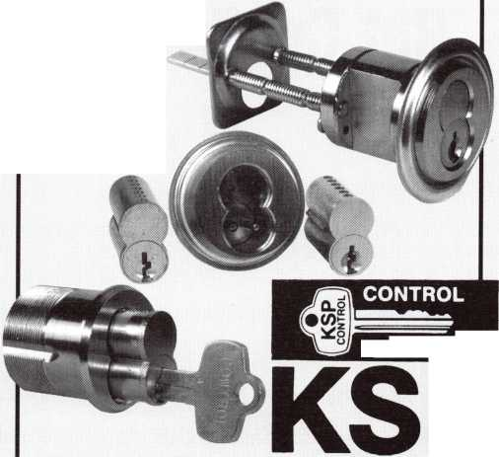

Success Breeds Confidence -

**But Confidence Also Breeds Success.**

Who knows which comes first? It takes confidence to make a buying decision. But, how can your customer have confi­dence in you, your product and your company unless you have confidence in yourself?

Confidence is hard to " fake." Lack of confidence shows in a persons' face, speech, gestures, and their exaggerated claims. Where does CONFIDENCE come from? Confidence comes from many areas; I will touch on several here in this article.

Preparation. A person, who is prepared to take advan­tage of every sales opportunity and is knowledgeable about their product or service, cannot help facing each sales interview with greater confidence than a person who lacks the necessary prepa­ration.

Practice. A person who spends hours practicing and pol­ishing a presentation on their given product or specialty, is bound to radiate more confidence when they face the prospec­tive sale. The one who is not quite sure of what they are going to say reflects uncertainty, and lack of conviction.

Time. It takes time to learn the fundamentals. Take the time to learn it right. Don't expect overnight success. We have enough self-proclaimed experts, who have read one book and then hit the streets thinking they know it all.

Knowledge. When you know your product or service from top to bottom, and exactly how it compares to the compe­tition. When you know so much about a customers' problem that you become sure you can help them, how can you help not be confident.

**By John C. Elliott, Jr., CML, CPS**

Education. While this might fit into the previous sec­tion, "Knowledge", it is however much different. You will never stop learning new ways, new things, or even and old way of doing something. Many times you find yourself with other locksmiths at the local lock supply house, chatting or swapping stories. If you have a local locksmith association, I would suggest that you join it, as at the meetings you will learn from those that have been in the industry for a number of years as well as the newbies, they all have something to offer. They have very good classes and of course great bull sessions where the new toys will be shown. I get so much knowledge this way. Most associations are based on education an training and will welcome you in even if you are not yet a locksmith, but are sponsored by one and regularly involved in some type of training. I have heard of people going into a lock­smith shop and after several meetings actually working for a very minimum wage or even for free just to learn. They would do everything from sweeping the floor, be a gopher for tools etc., to helping drill open the safe at the local grocery store. There are trade shows, usually hosted by a lock supplier. They show off all of the latest equipment and tools, but best of all, they will have some great classes given by manufactures on their products as well as other classes offered by the locksmith association(s).

If there is something you are better at, then learn all you can about it. Learn about the related areas and so on, as no matter how much you learn about something, there is always something else to learn about it.

Are you a shade less confidant than you would like to be?

Keynotes

October 2001

Is it caused by failure in any one of the aforementioned  
areas? If you believe a remedy is needed and you have  
made up your mind to do something, then get with it.  
It costs you money not to be prepared.

Confidence on your part breeds confidence  
on the part of your customer. A confident attitude  
breaks down the barriers of uncertainty, and disbelief.  
With these barriers out of the way, you can have a  
straight road for telling a convincing story about your  
product and services.

The Associated Locksmiths of America, is an  
organization prepared to help its members with any  
problems they may encounter. Whether it is in a tech-  
nical manner, or in the area of sales, they are ready to  
help. The Association has resources available to edu-  
cate the locksmith and enable that person to be pre-  
pared. Classes in many areas are offered through local  
association meetings, and at the national convention  
which is held in different cities every year. They have a  
testing program, called the Proficiency Registration  
Program or PRP for short. When taken, it tests the  
knowledge that a person in the locksmith field should  
know and shows this person the areas in which they  
need to polish on or learn. Remember this, your cus-  
tomers) are the real test.

I urge you to become involved in your future.  
Learn all you can, as then you will be prepared, and at  
your best for anything. You see your training and edu-  
cation will never stop. I have been doing this for 33  
years and am continuously learning new things.  
Practice your specialty learn all you can and become  
confident in yourself.

fnnmj

%

“Weighs” in BIG!

Enjoy the new technology from ABUS!  
Using the 83 Series Pinning Window™ Cylinder!

Unique  
“Tear Drop

Design

* Yale 8®
* Kwikset®
* Schlage C®
* Schlage C-L®
* Corbin®
* Sargent®
* Arrow®
* Russwin®
* Weiser - Falcon
* Z-Bar®

with

.>£1 #83'55 **order**

(a bus)

N- 8 3/55

HARDENED

NEW

OLDER

Order the NEW “83/55” in any keyway from

your distributor! Receive a FREE ABUS ($7.99)

Trigger Lock for each # 83/55 ordered! **That’S a 55% Savings!**

**HURRY** while supplies last! Promotion ends - June 30, 2001

For ordering information:

ABUS Lock USA 1-800-352-2287

**[www.abus.com](http://www.abus.com)**

1 .****. AT

n



October 2001

***Keynotes*** 133

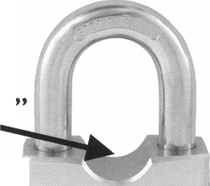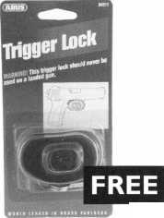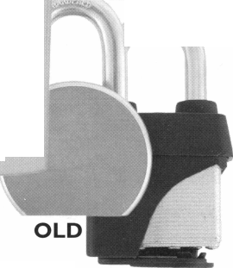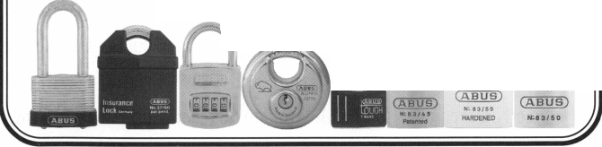

Charles Hudecek is "THE" locksmith at Cameron University in Norman, Oklahoma. Cameron University is a school of approximately 5000 students with about 60 buildings to maintain. Among them are two 10-story buildings, and two off campus annexes. Recently, I had the pleasure to visit with Charles in Arlington, Texas, and took that opportunity to ques­tion him about his work at Cameron and how he came to be where he is.

Charles became involved in locks, and security matters while in the military. As a career Army man of 22 years, his job involved doing things "that he can't yet talk about" but it suffices to say that Charles' skills involved being able to go undetected behind enemy lines, and "get into things and then back out" without anyone knowing about it. To do this, you have to know a lot about locks. As one of his military instructors told him, "Opening a lock involves being able to imagine yourself inside the lock and seeing how it works."

In 1994, when he decided to retire from the Army, Charles and his wife sat down and made a list of all the things that he was qualified to do, which I understand was a list of several pages. Then, she crossed off everything that she wouldn't let him do, (including "anything to do with guns"). Then, he crossed off everything left that he wouldn't do, and picked lock- smithing from that remaining list as being something that he liked, was experienced in, and was challenging to him. Charles prepared well, and accumulated his tools and stock over a peri­od of time prior to opening his shop.

Charles opened his shop so that opening day corre­sponded with the new phone book yellow page ads, and as he said, there was almost no transition at all. With the new yellow page out, he was up and running immediately and for the next several years, he worked on all phases of locksmithing, with his

son coming into the business a couple of years later. Their focus was on commercial, industrial, detention and institutional work. In the surrounding area, there were detention facilities, industri­al plants and Cameron University. Cameron initially called him to tend to problems that were beyond the capabilities of their staff and came to really like his work and ability to deal with the University environment. As time went on, Cameron became one of his regular and larger customers. It got to the point where he was putting a locksmith there for half a day, three days a week. Two years ago, when Cameron's Key Control person graduated from the classes that he had been taking on the side while work­ing at the school, Cameron took the step and made Charles an offer that he just couldn't refuse. He went to work full time as the University locksmith, and ultimately, turned over his com­mercial locksmith business to his son who still runs it today.

According to Charles, he had been wanting to "step back" from the everyday routine of commercial locksmith work to get more into Detention type Institutional locksmithing, and Forensic locksmithing and to further his education in those areas. A full time job with Cameron was just the thing to give him time to study.

While the Maintenance Engineering Department at Cameron involves a number of people, including carpenters, and other trades people, Charles is the only locksmith, key control, and hardware person. He has had to re-establish key control and has found one of the difficulties is to make the administra­tion aware of the need for true access control. Charles indicat­ed that it is tough dealing with people who have been used to having free access and master keys and now suddenly don't. As many have found in institutional work, he found that many of the University staff egos and perceived status are quite dependent on the level of master key that they have or can finagle. Feelings get

Keynotes

October 2001

hurt when people do not have the unrestricted access that they once had.

When asked what one of the least things he likes about his job, he says it is the arrogance of some of the professors. When asked what he most likes about what he is doing now, he said "Not having the pressure of having to chase the almighty dollar every minute," and having a regular workday with time for himself and family.

Charles likened the conditions at that University to those he encountered when starting his shop in a small town near Norman. The college had not had a dedicated position for locksmith before him. The "Key Control Person" had been a uni­versity maintenance worker who was sent to Yale Security Group's weeklong maintenance course. While dedicated and sin­cere, he had been short on training. Consequently, proper lock­smith practices had not been observed and as a result, the secu­rity, locks, key control, and hardware had suffered. According to Charles, the big problem has been to make people in adminis­tration and among the faculty aware of what a locksmith does, and to condition them to using a locksmith properly. To Charles, this experience has been much like starting up a business in a small town that has not had a local locksmith before.

I asked Charles if he ever got to do any preventative maintenance? He said that was something that he did when he had time between "putting out brushfires" and tending to every­day emergencies. Charles said that even two years into his tenure there, he was still in a "damage control mode", tending to violated master key systems, and worn hardware dating back for many years. A full-blown preventative maintenance program is still something planned for the future.

Cameron University has a mix of locks including some Small Format Interchangeable Core (SFIC) locks in the dorms, but mostly old cast iron Yale mortise locks in the rest of the school. Charles seems to like to work with the Yale hardware, and appreciates the good quality locks. When asked whether he would rather work with the newer SFIC locks, he says, "No, not

really. I kind of like the old stuff." Does he stay busy? You bet. He says that there is always something to do, and "each day is a brand new world."

A routine day for Charles involves all the jobs that any institutional locksmith does. This includes tending to any emer­gencies on campus, in addition to key generation, key cutting, installing and master keying new locks and hardware, and admin­istering the key control needs of the University. Occasionally, he even opens a car on campus. Because he is both hands-on tech­nician, and administrator, he pretty much runs sets his day's schedule and priorities based on the needs of those requesting work. He uses mostly his own tools, Van and key machines as a part of the deal worked out with the University. He is compen­sated for their use "very adequately", he said with a smile.

Charles has not limited his activities and talents to sim­ply working at the University. He is an active member of the Associated Locksmiths Of America (ALOA), the Oklahoma Master Locksmith Association (OMLA), and the Texas Locksmith Association (TLA). Charles currently serves his fellow locksmith as Education Director for the OMLA, setting up training classes designed to aid in the PRP, and as a Nominating committeeman for the TLA. His skill and wisdom have been of great value to the associations that he works in. He is an active student of Forensic Locksmithing, and has participated actively in investigations in and around the University. He often shares his experience and ability with the public and beginning locksmiths by dispensing advice online on Locksmith.com .

Asked how he likes institutional work, Charles Hudecek says that this is what he wants to do for the foreseeable future. The pay and the benefits are what he wants, and he likes institu­tional work. He enjoys his life as an Oklahoma Institutional Locksmith.

Cameron University 2800 West Gore Boulevard Lawton Oklahoma 73505-6377 (580) 581-2200

October 2001

***Keynotes***

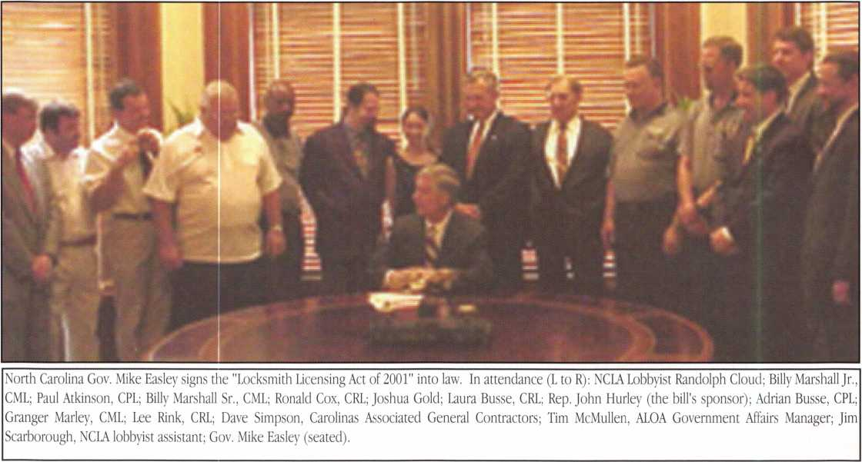

NORTH CAROLINA BECOMES LATEST STATE TO  
PROTECT LOCKSMITHS!

On Wednesday, August 16, 2001, North Carolina Governor Michael Easley signed into law the "Locksmith Licensing Act" of 2001. ALOA's Government Affairs Department worked closely with its Legislative Action Network members in the state, the North Carolina Locksmith Association (NCLA) and the NCLA lob­byist to make this dream a reality.

State Representative John W. Hurley sponsored this bill, intro­ducing it on March 29, 2001. In just five short months the bill weaved it's way through five committees and six floor votes. But the story of how locksmiths got this bill passed begins many years back.

The first attempt at licensing legislation was made in 1991 when several NCLA members met and had a bill drafted based on the ALOA model, Dade County, Florida and other statutes they had

gathered. This bill was eventually introduced through a cousin of Billy Marshall, Sr., CML, Elaine Marshall, who is now the North Carolina Secretary of State. Unfortunately, the bill disappeared in a committee and never resurfaced.

A couple of years later NCLA revived the effort. They suffered a couple of setbacks but finally got some action started again in 1998 during a short session, which didn't move the bill forward. Progress was made in 1999 regular session and 2000 short ses­sion where they managed to get it carried over without having to start at square one again. The 2001 session is where all the ducks were in a row. NCLA had hired a lobbyist, Ballard Everett to work the bill through the halls of the legislature the first couple of years. He was successful in bringing to representatives' attention that locksmiths were, in fact, not licensed in North Carolina and that anyone could become a locksmith without any training or criminal background check. Lobbyist Randolph Cloud and his assistant Jim Scarborough took it from there and made it through

Keynotes

October 2001

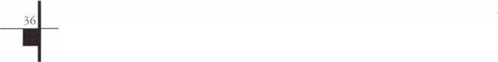

Just a Few

of the Many Titles Available..

PRP Resource Guide $25.00

Fundamentals of Master Keying $55.00

Simplex Unican

Manipulation Manual $39.00

Locksmithing:

From Apprentice to Master $27.00

Logical Lock Diagnostics $29.95

Safe Deposit Depth and

Space Manual $ 1 20.00

Safe Deposit adapter kit for use with the

Safe Deposit Depth and Space Manual

and the HPC 1 200CM $85.00

Safe Technicians

Reference Manual $156.00

How to Pick Lever Locks $1 9.95

**Visit our Website or call to place your order today!**

**[www.aloa.org](http://www.aloa.org) • (214)827-1701 x23 • (800)532-2562 x23**

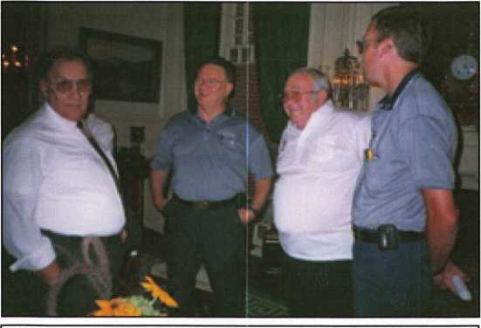

Adrian Busse, CPL; Granger Marley, CML; Lee Rink, CRL; Billy Marshall Sr., CML talk about the history of this moment before the bill signing ceremony held at the Governors Mansion.

some difficult hurdles. One of the biggest was creating another licensing board. In recent years, legislators have winced at the idea of creating any more boards or commissions. Through the hard work of Laura Busse, CRL, the Legislative Committee on New Licensing Boards over-whelmingly approved the idea of creating a locksmith licensing board.

date of this act, and sets fees at a reasonable $33 a year!

The Locksmith Licensing Board created by this new law is made up of nine members: three industry professionals chosen by the state House, three industry professionals chosen by the state Senate, and three public members chosen by the Governor. The public members cannot be trained or experienced in locksmith services, have a financial interest in a locksmith business, or be the spouse of a person who is so trained or experienced or has such an interest. To be appointed, you must have at least five years’ experience in locksmith services.

If you are interested in serving on the licensing board, please contact your state Representative or Senator. Not sure who that is? You can find out your representatives at: [www.ncga.state.nc.us/html2001/Representation/WhoRepresents](http://www.ncga.state.nc.us/html2001/Representation/WhoRepresents) Me/index.html

Congratulations locksmiths in North Carolina, you are now a rec­ognized profession!

During the process, many NCLA members and Legislative Action  
Network (LAN) members contacted their legislators to support  
the bill. Local manufacturers and distributors also came on board  
to support the bill. Raleigh ALOA members, Laura, Jeanette and  
Adrian Busse kept tabs on what was going on by attending all the  
committee hearings and all the floor debates.

This historic piece of legislation, will protect locksmiths from  
other professions encroaching on the industry by creating a def-  
inition of locksmiths that includes access control, creating a  
licensing board made up primarily of locksmiths, requiring back-  
ground checks for a license and protecting locksmiths from lia-  
bility. The law contains a generous "grandfather clause" for per-  
sons who have been actively engaged as a locksmith in North  
Carolina for at least two consecutive years prior to the effective

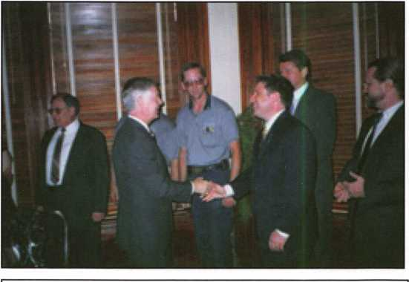

ALOA Government Affairs Manager, Tim McMullen thanks Gov. Easley for rec­ognizing and protecting locksmiths as a profession in North Carolina



Keynotes

October 2001

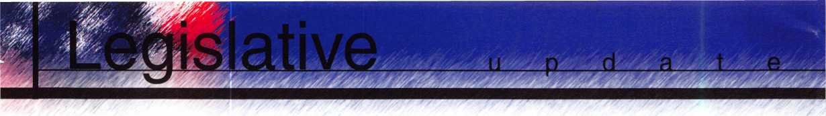

LEGISLATIVE UPDATE

All Bills That Saw Movement Between 07/01/2001 and 09/01/2001

CALIFORNIA S22

Increases fees and fines for violations of the Private Security Services Act by locksmiths, private investiga­tors, private security services, private patrol operators and alarm companies. Imposes fines on private patrol operators for violation of certain operating require­ments. Deletes provisions regarding agency regula­tion of fees and fines. Relates to the required arrest training courses required to persons entering into the security services arena.

STATUS: 09/06/2001 In SENATE. SENATE refused to concur in ASSEMBLY amendments. Motion to reconsider.

* This bill raises fees for violations of this act by 400% (i.e. from $25 to $100), and establishes any examina­tion fee at the actual cost of administering the test. The current law places a cap of $25 for the examina­tion fees.

CONNECTICUT S1323

Concerns telecommunications infrastructure layout technicians and the registration of employees of telecommunications providers; establishes licensing programs for telecommunications infrastructure lay­out technicians.

STATUS: 07/06/2001 Signed by GOVERNOR.

* ALOA was instrumental through working with ESA participants in getting Home Improvement Contractors (which locksmiths fall under) written out of this act.

NORTH CAROLINA H942

Establishes the locksmith licensing act (see preceed- ing story.)

STATUS: 08/15/2001 SIGNED by Governor.

MasterLink Security Products

ROGER ALEXANDER-TUTTLE  
“...understanding the needs of locksmiths...”

Mortise/Rim/Knob Cylinders • Storefront Door Hardware  
Cabinet Locks • Chain • Key Blanks • Padlocks • Pins ...and more

Local: (954) 730.9669 • Toll Free: (877) 347.9669  
Fax: (954) 486.0575

e-mail: [masterlink@mindspring.com](mailto:masterlink@mindspring.com)

3863 NW 19th Street, Lauderdale Lakes, FL 33311

It's True

Marray has developed the first  
screwless door loop.

Aluminum ma­terial means true anodizing.

No off color powder coat­ing or painting

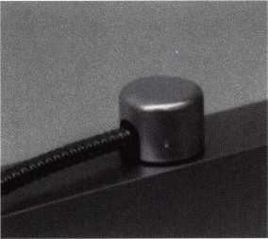

Standard 18” length. Can be ordered in cus­tom lengths

Plastic base stops shorts and pro­tects wires

Screwless base and cap means you drill two 1/2 inch diameter holes, pop the base into the hole, wire your system and snap on your covers. Simple as 1, 2, 3.

**Here’s the best part we are giving away a**

FREE SAMPLE TO THE FIRST 10O CALLERS WHO MEN­TION THIS ADD. A $14.40 WHOLESALE PRICE VALUE.

CALL TODAY, IT’S FREE!!

1-800-500-1449

Marray *enterprises, inc.*

At **Marray,** we’re not just modifiers, we’re Master Hardware Modifiers™  
1128 Walsh Ave., Santa Clara, CA 95050. **[www.marray.com](http://www.marray.com)**

October 2001

***Keynotes*** 39

ade

■EMPLOYMENT

Service Tech Wanted

Long Beach, CA. area experienced in all  
phasis required. Camera Technician a big  
plus!

Call Jack at (562) 597-8888

Safemasters

A nationwide industry leader, has §

opportunities available for ex]

technicians knowledgeable juadBlf of the  
following specialties: Agjps Control,  
CCTV, Safes, or Generallfcksmithing. As  
an innovative Far|||?friendly employer  
our employees fjljoy flexible scheduling,  
401(k) and compahymatch, health, dental  
and vision insuranC%sLong and Short  
Term disability insuranceyyompany vehi-  
cles, opportunities for advancement, com-  
pany paid training programsptlschnical

skills updates, new product trainin;

schools and college courses, gene:

leave programs, etc. We are committed to  
our associates and their families as we  
stand side by side in sharing the rewards  
of hard work and customer friendly pro-  
fessional service, with all our associates.  
Our team effort makes Safemasters an  
enjoyable career experience which pro-  
vides many opportunities to advance your  
career, your skills, your personal life. We  
hold our associates in the highest esteem  
because we know they are the best in the  
industry and take pride in a job well done.  
It is through this dedication and loyalty  
that we continue to grow and expand  
offering all associates the stability of a  
company with over 60 years of experience,  
a committed team of support personnel to  
assist you in doing what you do best and a  
realistic approach to balancing your work  
and home life. We have locations in  
Maryland, Virginia, Wilmington (DE),

Philadelphia, Pittsburgh, Boston, New  
Jersey, Indianapcdtojpfta Chicago. Stop by  
one of our offigpind talk to the manager  
about vo**u^g**eds and how we can fill  
them^^pffl to our Headquarters at:

**Safem&ers, 2700 Garfield Avenue, Suite**

**Silver Spring, MD 20910, to the**

**fflittentim of Human Resources or email us**

**at hr@safemasters. com.**

Wanted Sales Superstar

Here We Grow Again! Bass Security Services, Inc. is looking for the best of the best. If you are an experienced, motivated, and no-nonsense sales professional with an extensive background in the security industry, we want YOU! All candidates must have a minimum of 7 years in the locksmith / security field, with a back­ground in sales and customer service. We offer: Top wages with excellent incentives, 401k, paid vacation and holidays, health enefits, and continued industry educa- Re-location assistance maybe provid­ed"

Contac

Bass Securififigrvices, Inc. Ph#2l6-755-l2^$fixt#128 Fax#216-755-122t e-mail/ [rmesniek@bcXHkgpurity.com](mailto:rmesniek@bcXHkgpurity.com)

Great benefits. Salary DOE. Please call  
and/or fax resume to:

James Rochester  
6207 Industrial Road

Las Vegas, NV 89118  
702/614-3939

702/614-8052 (fax) **,**

Experienced Lolfksmith Wanted

Las Vegas-based company that deals%ith all phases of surveillance, access corif and locksmithing is looking for a highly qualified and motivated individual to per­form locksmith duties. Vegas Valley Locking Systems Inc. has an established customer base and is expanding. Qualified individuals will have extensive experience in locksmithing, safes, and door hardware. Electronic hardware experience is a plus.

Locksmith Want*

Looking for serious, dedicated profession­als to make at least $50K/year. Come to the cool Gulf shores of Houston, TX. Home for all the great fishing, sun and fun you can stand. Home of low payroll taxes, low cost living and the good life. Great job opportunity for the right person. Offering fantastic pay, paid vacation and holidays, great bonus program and growth oppor­tunity in CCTV and alarms. Professional people with tools and vehicles.

Call 281/830-9441 or fax 713/266-4350.

Experienced Locksmith

Growing, established 22-year company is seeking lead locksmiths. Experience required in commercial locksmithing, including safe work and electronic access,CCTV, panic hardware, master key systems. Work in and around the nation’s Capitol. Excellent opportunity for individ­ual dedicated to the trade and to cus­tomer service. Company provides vehicle, tools and uniforms. Salary commensurate with experience. Paid holidays, vacations, health insurance and 401(k). **Please fax Resume to 301/424-3080 or call toll free 888/424-LOCK (5625).**

Locksrhith for Hire

Northern NeW Jersey Locksmith looking for employment ’With quality company. Experience with most hardware including Medeco.

Jim Nasta at 973/815-1627.

***Keynotes***

October 2001

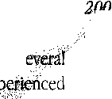

Wanted

Experienced Technicians

Lock into your future now! If you are an experienced, intelligent technician, and desire a secure future, come join our team. We are a full service commercial / residential security service (locksjkeys,safes,access control,cctv,all door related hardware,alarm systems) We offer: large sign on bonus, top wages, company vehicle, 401k, paid vacation and holidays, health benefits, new uniforms, cross training, and JOB SATISFACTION. We are looking for the best tech's who are ready to be treated and compensated as professionals. Contact: Bass Security Services, INC.

ph#216-755-1200 ext#128 fax#216-755-1220 toll free #800-523-1422 e-mail / [rmesnick@bass-security.com](mailto:rmesnick@bass-security.com)

■WANTED TO BUY/SELL

For Sale

100-ACE Realtor, over the door lock boxes All keyed alike - only $3 each. Call, Key Hole at 806/352-2157. Weekdays only, 8:30 a.m. to 5:30p.m.

Wanted: Auto Key Blanks

Wanted - old auto key blanks, Hurd, Briggs & Stratton, Yale. Will pay $1 each. Douglas Vogel, 4779 Meadowlark Lane, Dexter, MI, 48130.

For Sale

Buy things you need from my inventory and save 50 percent off wholesale.

Call the Post Key Co toll free at 888/949- 7089

Acement Locks Available

300 Double Little Nose (DLN) Lock

For 1/2" doors, Available in brass

7737 Double Little Nose (DLN) Lock For 3/8" doors, Available in brass or nickel

7750 Double Little Nose (DLN) Lock For 1/2" doors, Available in brass

7750 Double Big Nose (DBN)lock For 1/2" doors, Available in brass

PL 80 Cabinet Lock Furnished with chrome faceplate

To place an order, call Bullseye SD Locks at Ph# 1-800-364-4899 or email Jim Taylor today at [bullseyesdlocks@aol.com](mailto:bullseyesdlocks@aol.com) MasterCard and Visa accepted 2033 Parasol Drive, Lexington, KY 40513 Ph# 859-224-4898, Fax# 859-224-1199

■BUSINESSES FOR SALE

Business for Sale

Mobile locksmith business for sale, retir­ing, established 15 years. Western Maryland year-round resort area. Lake and ski resort nearby. Fast-growing area. Only full-time locksmith in area.

Call 301/387-6026.

For Sale

Established locksmith business for sale in Pembroke Pine, FL. Same location since 1972. The store comes with equipment, two vans and residential and commercial accounts. Grosses over $100K per year. Serious inquiries only. Please contact Peter at954/962-4535-

Business Opportunity

Associated Locksmith Network, Corp. is looking to subcontract locksmith compa­nies around the nation and in the

Caribbean. If interested, request an appli­cation now at New Accounts (AL0100) atP.O. Box 771296, Miami, FL 33177-9998

For Sale

Mobile Locksmith Business. Over $100K in sales annually. Records available for van and inventory. Master keying a must. Access control, safe deposit, and safe experience.

Call 816/452-5309■ Kansas City, MO area North

**Classified  
Advertising Policy**

Classified advertising space is provided free of charge to ALOA members, and for a fee of $.60 per word, $15 minimum for non-members. Classified ads may be used to advertise used merchandise and over­stocked items for sale, “wanted to buy” items, business opportunities, employ­ment opportunities/positions wanted and the like. Members or non-members wishing to advertise services or new mer­chandise for sale may purchase a “Commercial Classified Ad,” for a fee of $1.30 per word, with a minimum of $40. Each ad will run for two issues. For blind boxes there is a $5 charge to members and non-members. All ads must be sub­mitted in writing to the ALOA office by the fifteenth of the month, two months prior to issue date. Send to Keynotes Classifieds, 3003 Live Oak St., Dallas TX 75204-6186. ALOA reserves the right to refuse any classified advertisement that it deems inappropriate according to the stated purpose of the classified advertis­ing section.

October 2001

***Keynotes***

MANUFACTURERS



m

m

b e r s

•A & B Safe Corp.

(800) 253-1267 FAX (856) 863-1208

•Abloy Door Security

(514) 335-9500 FAX (514) 335-0430

•Adams Rite Manufacturing Co.

(800) 872-3267 FAX (800) 232-7329

•Adesco Safe Manufacturing Co.

web: [www.adesco.com](http://www.adesco.com) (800) 821-6803 FAX (562) 408-6427

•Adrian Steel Company

web: [www.adriansteel.com](http://www.adriansteel.com) (800) 677-2726 FAX (517) 265-5834

•Alarm Lock Systems, Inc.

(800) ALA-LOCK FAX (516) 789-3383

•American Lock Co.

(708) 534-2000 FAX (708) 534-0531

•American Security Products (AMSEC) (800) 423-1881 FAX (909)685-9685

•Baldwin Hardware Corp.

(610) 796-4012 FAX (610) 796-4493

•Buddy Products

(800) 886-8688 FAX (312) 733-8356

•BWD Automotive

(334) 872-6524 FAX (334) 874-6011

•COMPX Security Products

(864)297-6655 FAX (864)297-9987

•Curtis Industries

(800)-555-5397 FAX (800) 867-6020

•DETEX Corporation

(800)729-3839 FAX (830)620-6711

•DORMA Architectural Hardware

FAX (717)336-3881 (717)336-3500

•Don-Jo Manufacturing, Inc.

(978)422-3213 FAX (978)422-3467

•Doyle Security Products

(800)333-6953 FAX (612)521-0166

•DSC Group of Companies

(905) 760-3000 ext. 2200 FAX (905) 760-3040

•Door Controls International

(800) 742-3634 FAX (800) 742-0410

•ESP Lock Products, Inc.

(978) 537-6121 FAX (978) 534-9109

•Ewert Wholesale Hardware

(800 )451-0200 FAX (708) 597-0881

•Fairway Supply, Inc.

(214) 350-0021 (214) 352-4299

•H.L. Flake Co.

(800) 231-4105

•HES, Inc.

(623) 582-4626 (623) 582-4641

•Hardware Agencies, Ltd.

(416) 462-1921

•Hongtai Lock Co Ltd.

(137)238-1414 FAX (208)793-3856

•HPC, Inc.

(847)671-6280 FAX (847) 671-6343

•Ilco Unican

(252) 446-3321 FAX (252) 446-4702

•Intellikey

(800) 226-0703 FAX (407) 724-0811

•Jensen Tools Inc.

(602) 453-3169 FAX (602) 438-1690

•Jet Hardware Mfg. Co

(718) 257-9600 FAX (718) 257-0973

•KABA High Security Locks

(860) 621-3601 FAX (860) 621-9727

•KEY-BAK; Div. of W. Coast Chain Mfg.

(909) 923-7800 FAX (909) 923-0024

•Knaack Manufacturing Co.

(800) 456-7865 FAX (815) 459-9097

•LAB Security

(800) 243-8242 FAX (203) 583-7838

•LCN Closers (Division of Ingersol)

(815) 875-3311 FAX (815) 879-1497

•La Gard, Inc.

(310) 325-5670 FAX (310) 325-5615

•Lucky Line Products

(619) 549-6699 FAX (619) 549-0949

•Locksmith Ledger International

(770) 886-0800 FAX (770) 889-7703

•M.A.G. Engineering & Mfg. Inc.

(714) 891-5100 FAX (714) 892-6845

•MARKS USA

(516) 225-5400 FAX (516) 225-6136

•MARRAY ENTERPRISES

(408) 970-0213 FAX (408) 970-8767

•Master Lock Company

(414) 444-2800 FAX (414) 449-3114

•Medeco Security Locks

(540) 380-5000 FAX (540) 380-5010

•Meilink Safe Company

(800) 634-5465 FAX (800) 896-6606

•MMD Inc.

(865) 428-3611 FAX (865) 453-4136

•MCS Communication Systems

(514) 444-2040 FAX (514) 444-2029

•Massglass & Door Service

(888) 742-8837 FAX (818) 991-5742

•Monaco Lock Co.

(800) 526-6094 FAX (800) 845-5625

•Mul-T-Lock USA, Inc,

(800) 562-3511 FAX (973) 778-4007

•ROFU International Corp.

(800) 255-7638 FAX (253) 922-1728

•Rutherford Controls Int'l. Corp.

(757)427-1230 FAX (757) 427-9549

•STRATTEC Security Corp.

(414) 247-3333 FAX (414) 247-3329

•Sargent & Greenleaf, Inc.

(606) 885-9411 FAX (606) 887-3063

•Sargent Manufacturing

(203) 562-2151 FAX (203) 776-5992

i

Keynotes

October 2001

•Schlage Lock Co.

(800) 847-1864 FAX (800) 452-0663

•Schwab Corporation

(765) 447-9470 FAX (765) 447-8278

•Securitron Magnalock Corp.

(800) 624-5625 FAX (775) 355-5636

•Security Door Controls

(805) 494-0622 FAX (805) 494-8861

•Security Solutions

(405) 376-1600 FAX (405) 376-6870

•Sentry Group

(716) 381-4900 FAX (716) 381-8559

•Somerset Security Products

(800) 881-5206 FAX (800) 206-9949

•Sully Tools Inc.

(703) 689-3416 FAX (703) 787-0869

•Sun-IL Gum Go

823-194-59300 FAX 823-194-59400

•Taymor Industries, Inc.

(800) 388-9887 FAX (800) 288-8133

•The National Locksmith

(630) 837-2044 (630) 837-1210

•Trine Products Corporation

(718) 829-2332 FAX (718) 829-6405

•Videx, Inc.

(541) 758-0521 FAX (541) 752-5285

•W-Lok Corporation

(616) 355-4015 FAX (616) 355-4295

•Yale Security Inc.

(800) 438-1951 FAX (800) 338-0965

DISTRIBUTORS

•Accredited Lock Supply Co.

(800) 652-2835 FAX (201) 865-5031

•Ace Lock & Security Supply Co.

(800) ACE-LOCK FAX (800) ACE-FAX4

•ADI

(516) 692-1000 FAX (516) 692-3457

•Andrews Wholesale Lock Supply

(717) 272-7422 FAX (717) 274-8659

•Boyle & Chase Inc.

(800) 325-2530 FAX (800) 205-3500

•Clark Security Products, Inc.

(800) 854-2088 FAX (619) 974-5284

•Cook’s Building Specialties

(505) 883-5701 FAX (505) 883-5704

•Dire’s Lock & Key Co.

(303) 294-0176 FAX (303) 294-0198

•Direct Security Supply, Inc.

(800) 252-5757 FAX (800) 452-8600

•Doyle Security Products

(800) 333-6953 FAX (612)521-0166

•Dugmore & Duncan Inc.

(888) 384-6673 FAX (888) 329-3846

•E. L. Reinhardt Co., Inc.

(800) 328-1311 FAX (612) 481-0166

•Foley-Belsaw Company

(800) 821-3452 FAX (816) 483-5010

•Fried Brothers, Inc.

(800) 523-2924 FAX (800) 541-3489

•HS&S Wholesale Distributors

1(800) 521-2202 FAX (313) 342-7580

•Hans Johnsen Company

(214) 879-1550 FAX (214) 879-1530

•Howard Keys

(704) 509-4944 FAX (704) 509-6248

•IDN, Inc.

(817) 421-5470 FAX (817) 421-5468

•Intermountain Lock & Supply Co

(800) 453-5386 FAX (801)485-7205

•Jo-Van Distributors Inc.

(416) 752-7249 FAX (416) 752-3845

•Lockmasters, Inc.

(800) 654-0637 FAX (859) 885-7093

•Locks Company

(800) 288-0801 FAX (305) 949-3619

•The Locksmith Store Inc.

(847) 364-5111 FAX (847) 364-5125 •M. Zion Company (212) 349-8677 FAX (212) 964-0495

•McDonald-DASH Locksmith Supply

(800) 238-7541 FAX (901) 366-0005

•McManus Locksmith Supply, Inc.

(702) 333-9112 FAX (704) 332-8664

•Marray Enterprises

(408) 970-0213 FAX (408) 970-8767

•Omaha Wholesale Hardware

(800) 238-4566 FAX (402) 444-1644

•Securite.com

(800) 241-3930 FAX (858) 974-5269

•Sentry Security Fasteners

(309) 693-2800 FAX (309) 693-2872

•Southern Lock and Supply Co.

(800) 237-2875 FAX: (800) 447-2299

•Stone & Berg Wholesale

(800) 225-7405 FAX (800) 535-5625

•Strauss Safe & Lock Company

(515) 276-7030 FAX: (515)276-7031

•Taylor Securtiy & Lock Co.

(301) 948-7670 FAX (301)948-1029

•Timemaster, Inc.

(800) 798-8464 FAX (800) 798-8463

•Top Notch Distributors, Inc.

(800) 722-4210 FAX (800) 248-3620

•U.S. Lock Corporation

(800) 925-5000 FAX (800) 338-5625

•Webster Safe & Lock Company, Inc.

(901) 332-2911 FAX (901) 332-2878

SERVICE

•Allstate Insurance Company

(847) 402-8196 FAX (847) 326-7509

October 2001

Keynotes

About the Authors

Claire Cohen,

the second woman to become a CML, has  
been in locksmithing since 1977 and has  
been writing articles for Keynotes since  
1987. She is alos a contributing editor for  
Keynotes, and was just named the 2001

Keynotes Author of the Year - again, the second woman  
to achieve that honor.

CliffordD. "CD."Lipscomb, CML, CPS, has been working in the physical security industry since 1974 as an institutional locksmith and currently as owner of a full-service locksmith business in Corsicana, TX. An ALOA member since 1990, C.D. is an ALOA ACE certified instructor and has taught for many locksmith associations, including the Texas Locksmith Association and the Greater Dallas Locksmith Association. He also has has held various volunteer offices with GDLA and TLA.

Greg Perry, CML, CPS,

——| has been in the locksmith industry for 18 ||^Hp years. He's spend half of that time as a BP field technician for Security Engineering Hll in Ridgecrest, Calif. Greg is also a past president of the Desert Counties Chapter of the California Locksmiths Association.

John C. Elliott, Jr., CML, CPS, is an ALOA member who is Vice Chairman of the Georgia Chapter of ALOA, and a 29-year member of the association.

AD INDEX

|  |  |
| --- | --- |
| Assa | 9 |
| Assa | 11 |
| Turn 10 | 12 |
| Yankee | 19 |
| KSP | 31 |
| JLM Wholesale | 31 |
| Abus | 33 |
| MasterLink | 39 |
| Marray Enterprises | 39 |
| Hickock Inc. | BC |

Ken Holmlund, CRL,

a long-time ALOA member, owns and operates Holmlund's Lock and Safe in Miles City, MT.

Don Dennis, CPL,

has been dealing with the locksmithing profession since 1972 with a four-year apprenticeship in New Mexico. He founded and has been the owner of Dennis Safe & Lock in Johnson City, TN, since 1977. He was the founder of East Tennessee Locksmith Association in 1988 and is currently chairman of the education com­mittee and editor of ETLA 's newsletter.

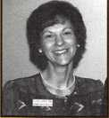

Keynotes

October 2001

**Reflecting**

**tomorrow**



rosemontjllinois



**July**

22-28

**2002**

**Rosemont**

**Convention**

**Center**

**Hyatt**

**Regency**

**O'Hare**

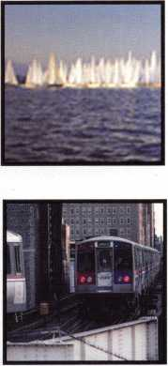

^fsS?e0PS

*J>rS£S*

' **Jump ahead of the competition at warp speed and see your profits soar.**

**Hickok’s New Generation STAR transports you with the factory tool for programming keys to  
Ford-Lincoln-Mercury and Mazda vehicles with passive anti theft systems (PATS).**

**^ Program vehicle keys through Model Year 2001 with Hickok’s NGS Model 800-8LA-$1995 ^ Update your existing software-the 2001 Complete New Model Ford Software Update Model 80LA-$895**

HICKOK

**800/342-5080**

INCORPORATED

**muiui.hickok-inc.com**

